UI.R

library(shiny)

library(highcharter)

library(leaflet)

require(ggthemes)

require(tidyr)

require(dplyr)

require(ggplot2)

d <- read.csv(file = "cities_r2.csv")

df <-separate(data = d, col = location, into = c("lat","lng"),sep = ",")

df.city <- df

df.state <- df.city %>%

group_by(state_name) %>%

summarize(Total = n(),

population_total = sum(population_total),

population_male = sum(population_male),

population_female = sum(population_female),

Male_Percent = population_male/population_total * 100,

Female_Percent = population_female/population_total * 100,

total_graduates = sum(total_graduates),

male_graduates = sum(male_graduates),

female_graduates = sum(female_graduates),

Grads_percent = total_graduates/population_total * 100,

Male_Grads_Percent = male_graduates/population_male * 100,

Female_Grads_Percent = female_graduates/population_female * 100,

X0.6_population_total = sum(X0.6_population_total),

X0.6_population_male = sum(X0.6_population_male),

X0.6_population_female = sum(X0.6_population_female),

literates_total = sum(literates_total),

literates_male = sum(literates_male),

literates_female = sum(literates_female),

sex_ratio = mean(sex_ratio),

child_sex_ratio = mean(child_sex_ratio),

lat = mean(as.numeric(lat)),

lng = mean(as.numeric(lng)),

effective_literacy_rate_total = mean(effective_literacy_rate_total),

effective_literacy_rate_male = mean(effective_literacy_rate_male),

effective_literacy_rate_female = mean(effective_literacy_rate_female)

)

df.city <- mutate(df.city,

Male_Percent = population_male/population_total * 100,

Female_Percent = population_female/population_total * 100,

Grads_percent = total_graduates/population_total * 100,

Male_Grads_Percent = male_graduates/population_male * 100,

Female_Grads_Percent = female_graduates/population_female * 100

)

list_select <- c("Population" = 1, "Male Population" = 2, "Female Population" = 3,

"Male Percentage" = 4, "Female Percentage" = 5, "Graduates" = 6,

"Male Graduates" = 7, "Female Graduates" = 8, "Graduates Percentage" = 9,

"Male Graduates Percentage" = 10, "Female Graduates Percentage" = 11,

"Total Literates" = 12, "Literates_Male" =13, "Literates_Female" = 14,

"Sex_Ratio" = 15, "Child_Sex_Ratio" = 16, "Effective_Literacy_Rate_total" = 17,

"Effective_Literacy_Rate_Male" = 18, "Effective_Literacy_Rate_Female" = 19)

var <- c(

"Total Population" = "tp",

"Male Population" = "mp",

"Female Populaion" = "fp",

"Total Population Age(0-6)"= "tc",

"Male Population Age(0-6)" = "mc",

"Female Population Age(0-6)"="fc",

"Total Graduates" = "TG",

"Male Graduates" = "MG",

"Female Graduates" = "FG"

)

fluidPage(theme ='styles.css',

navbarPage(title = "Analysis of Indian Population",

tabPanel(title = "Plots",

sidebarLayout(sidebarPanel( selectInput(inputId = "select", label = h3("Select Statistic"),

choices = list_select,

selected = 1),

radioButtons(inputId = "radio", label = h3("Select"),

choices = list("State" = 1, "City" = 2),

selected = 1),

numericInput("num", label = h3("Top"), value = 20),

actionButton("goButton","Plot")),

mainPanel(highchartOutput(outputId = "plot1",height = 700)

))),

tabPanel(title = "TreeMap",

sidebarLayout(sidebarPanel( selectInput(inputId = "select2", label = h3("Select Statistic"),

choices = list_select,

selected = 1),

radioButtons(inputId = "radio2", label = h3("Select"),

choices = list("State" = 1, "City" = 2),

selected = 1),

numericInput("num2", label = h3("Top"), value = 20),

actionButton("goButton2","Plot")),

mainPanel(highchartOutput(outputId = "treeMap",height = 700)

))),

tabPanel(title = "Data Grid",tabsetPanel(tabPanel(title = "States",

sidebarLayout(

sidebarPanel( checkboxGroupInput(inputId ='show_vars1', 'Columns in dataset to show:',

names(df.state), selected = names(df.city))),

mainPanel(dataTableOutput('mytable1'))

)

),tabPanel(title = "Cities"),

sidebarLayout(

sidebarPanel( checkboxGroupInput(inputId ='show_vars2', 'Columns in dataset to show:',

names(df.city), selected = names(df.city))),

mainPanel(dataTableOutput('mytable2'))

))

)

)

)

SERVER.R

library(shiny)

library(highcharter)

library(leaflet)

require(ggthemes)

require(tidyr)

require(dplyr)

require(ggplot2)

d<- read.csv(file = "cities_r2.csv")

dff <-separate(data = d, col = location, into = c("lat","lng"),sep = ",")

dff$name_of_city <- trimws(dff$name_of_city)

df.city <- dff

df.state <- df.city %>%

group_by(state_name) %>%

summarize(Total = n(),

population_total = sum(population_total),

population_male = sum(population_male),

population_female = sum(population_female),

Male_Percent = population_male/population_total * 100,

Female_Percent = population_female/population_total * 100,

total_graduates = sum(total_graduates),

male_graduates = sum(male_graduates),

female_graduates = sum(female_graduates),

Grads_percent = total_graduates/population_total * 100,

Male_Grads_Percent = male_graduates/population_male * 100,

Female_Grads_Percent = female_graduates/population_female * 100,

X0.6_population_total = sum(X0.6_population_total),

X0.6_population_male = sum(X0.6_population_male),

X0.6_population_female = sum(X0.6_population_female),

literates_total = sum(literates_total),

literates_male = sum(literates_male),

literates_female = sum(literates_female),

sex_ratio = mean(sex_ratio),

child_sex_ratio = mean(child_sex_ratio),

lat = mean(as.numeric(lat)),

lng = mean(as.numeric(lng)),

effective_literacy_rate_total = mean(effective_literacy_rate_total),

effective_literacy_rate_male = mean(effective_literacy_rate_male),

effective_literacy_rate_female = mean(effective_literacy_rate_female)

)

df.city <- mutate(df.city,

Male_Percent = population_male/population_total * 100,

Female_Percent = population_female/population_total * 100,

Grads_percent = total_graduates/population_total * 100,

Male_Grads_Percent = male_graduates/population_male * 100,

Female_Grads_Percent = female_graduates/population_female * 100

)

function(input, output, session) {

#data <- reactiveValues({})

output$value <- renderPrint({ input$select })

output$plot1 <- renderHighchart({

input$goButton

n<-isolate(input$num)

if(as.numeric(input$radio) == 1){

if(input$select == 1){

da <- df.state %>%

arrange(desc(population_total))

dp <- da[1:n,]

highchart() %>%hc_xAxis(categories = dp$state_name)%>%

hc_add_series(dp, type = "column",

hcaes(x = state_name, y = population_total, color = state_name))%>%

hc_title(text = "States by Population")%>%

hc_yAxis(title = list(text = "Population"))%>%

hc_add_theme(hc_theme_google())

}

else if(input$select ==2){

da <- df.state %>%

arrange(desc(population_male))

dm <- da[1:n,]

highchart() %>% hc_xAxis(categories = dm$state_name)%>%

hc_add_series(dm, type = "column",

hcaes(x = state_name, y = population_male, color = state_name))%>%

hc_title(text = "States by Male Population")%>%

hc_yAxis(title = list(text = "Male Population"))%>%

hc_add_theme(hc_theme_google())

}

else if(input$select ==3){

da <- df.state %>%

arrange(desc(population_female))

de <- da[1:n,]

highchart() %>% hc_xAxis(categories = de$state_name)%>%

hc_add_series(de, type = "column",

hcaes(x = state_name, y = population_female, color = state_name))%>%

hc_title(text = "States by Female Population")%>%

hc_yAxis(title = list(text = "Female Population"))%>%

hc_add_theme(hc_theme_google())

}

else if(input$select ==4){

da <- df.state %>%

arrange(desc(Male_Percent))

dmp <- da[1:n,]

highchart() %>% hc_xAxis(categories = dmp$state_name)%>%

hc_add_series(dmp, type = "column",

hcaes(x = state_name, y = Male_Percent, color = state_name))%>%

hc_title(text = "States by Males Percentage")%>%

hc_yAxis(title = list(text = "Males Percentage"))%>%

hc_add_theme(hc_theme_google())

}

else if(input$select ==5){

da <- df.state %>%

arrange(desc(Female_Percent))

dfp <- da[1:n,]

highchart() %>% hc_xAxis(categories = dfp$state_name)%>%

hc_add_series(dfp, type = "column",

hcaes(x = state_name, y = Female_Percent, color = state_name))%>%

hc_title(text = "States by Females Percentage")%>%

hc_yAxis(title = list(text = "Females Percentage"))%>%

hc_add_theme(hc_theme_google())

}

else if(input$select ==6){

da <- df.state %>%

arrange(desc(total_graduates))

dg <- da[1:n,]

highchart() %>% hc_xAxis(categories = dg$state_name)%>%

hc_add_series(dg, type = "column",

hcaes(x = state_name, y = total_graduates, color = state_name))%>%

hc_title(text = "States by Number Of Graduates")%>%

hc_yAxis(title = list(text = "Total Graduates"))%>%

hc_add_theme(hc_theme_google())

}

else if(input$select ==7){

da <- df.state %>%

arrange(desc(male_graduates))

dmg <- da[1:n,]

highchart() %>% hc_xAxis(categories = dmg$state_name)%>%

hc_add_series(dmg, type = "column",

hcaes(x = state_name, y = male_graduates, color = state_name))%>%

hc_title(text = "States by Male Graduates")%>%

hc_yAxis(title = list(text = "Male Graduates"))%>%

hc_add_theme(hc_theme_google())

}

else if(input$select ==8){

da <- df.state %>%

arrange(desc(female_graduates))

dfg <- da[1:n,]

highchart() %>% hc_xAxis(categories = dfg$state_name)%>%

hc_add_series(dfg, type = "column",

hcaes(x = state_name, y = female_graduates, color = state_name))%>%

hc_title(text = "States by Female Population")%>%

hc_yAxis(title = list(text = "Female Graduates"))%>%

hc_add_theme(hc_theme_google())

}

else if(input$select ==9){

da <- df.state %>%

arrange(desc(Grads_percent))

dgp <- da[1:n,]

highchart() %>% hc_xAxis(categories = dgp$state_name)%>%

hc_add_series(dgp, type = "column",

hcaes(x = state_name, y = Grads_percent, color = state_name))%>%

hc_title(text = "States by Graduates Percentage")%>%

hc_yAxis(title = list(text = "Graduates Percentage"))%>%

hc_add_theme(hc_theme_google())

}

else if(input$select ==10){

da <- df.state %>%

arrange(desc(Male_Grads_Percent))

dmgp <- da[1:n,]

highchart() %>% hc_xAxis(categories = dmgp$state_name)%>%

hc_add_series(dmgp, type = "column",

hcaes(x = state_name, y = Male_Grads_Percent, color = state_name))%>%

hc_title(text = "States by Male Graduates Percentage")%>%

hc_yAxis(title = list(text = "Males Graduates Percentage"))%>%

hc_add_theme(hc_theme_google())

}

else if(input$select ==11){

da <- df.state %>%

arrange(desc(Female_Grads_Percent))

dfgp <- da[1:n,]

highchart() %>% hc_xAxis(categories = dfgp$state_name)%>%

hc_add_series(dfgp, type = "column",

hcaes(x = state_name, y = Female_Grads_Percent, color = state_name))%>%

hc_title(text = "States by Female Graduates Percentage")%>%

hc_yAxis(title = list(text = "Females Graduates Percentage"))%>%

hc_add_theme(hc_theme_google())

}

else if(input$select ==12){

da <- df.state %>%

arrange(desc(literates_total))

dl <- da[1:n,]

highchart() %>% hc_xAxis(categories = dl$state_name)%>%

hc_add_series(dl, type = "column",

hcaes(x = state_name, y = literates_total, color = state_name))%>%

hc_title(text = "States by Total Literates")%>%

hc_yAxis(title = list(text = "Total Literates"))%>%

hc_add_theme(hc_theme_google())

}

else if(input$select ==13){

da <- df.state %>%

arrange(desc(literates_male))

dlm <- da[1:n,]

highchart() %>% hc_xAxis(categories = dlm$state_name)%>%

hc_add_series(dlm, type = "column",

hcaes(x = state_name, y = literates_male, color = state_name))%>%

hc_title(text = "States by Male Literates")%>%

hc_yAxis(title = list(text = "Male Literates"))%>%

hc_add_theme(hc_theme_google())

}

else if(input$select ==14){

da <- df.state %>%

arrange(desc(literates_female))

dlf <- da[1:n,]

highchart() %>% hc_xAxis(categories = dlf$state_name)%>%

hc_add_series(dlf, type = "column",

hcaes(x = state_name, y = literates_female, color = state_name))%>%

hc_title(text = "States by Female Literates")%>%

hc_yAxis(title = list(text = "Female Literates"))%>%

hc_add_theme(hc_theme_google())

}

else if(input$select ==15){

da <- df.state %>%

arrange(desc(sex_ratio))

ds <- da[1:n,]

highchart() %>% hc_xAxis(categories = ds$state_name)%>%

hc_add_series(ds, type = "column",

hcaes(x = state_name, y = sex_ratio, color = state_name))%>%

hc_title(text = "States by Sex Ratio")%>%

hc_yAxis(title = list(text = "Sex_Ratio"))%>%

hc_add_theme(hc_theme_google())

}

else if(input$select ==16){

da <- df.state %>%

arrange(desc(child_sex_ratio))

dcs <- da[1:n,]

highchart() %>% hc_xAxis(categories = dcs$state_name)%>%

hc_add_series(dcs, type = "column",

hcaes(x = state_name, y = child_sex_ratio, color = state_name))%>%

hc_title(text = "States by Child Sex Ratio")%>%

hc_yAxis(title = list(text = "Child_Sex_Ratio"))%>%

hc_add_theme(hc_theme_google())

}

else if(input$select ==17){

da <- df.state %>%

arrange(desc(effective_literacy_rate_total))

del <- da[1:n,]

highchart() %>% hc_xAxis(categories = del$state_name)%>%

hc_add_series(del, type = "column",

hcaes(x = state_name, y = effective_literacy_rate_total, color = state_name))%>%

hc_title(text = "States by Total Effective Literacy Rate")%>%

hc_yAxis(title = list(text = "Effective_Literacy_Rate_total"))%>%

hc_add_theme(hc_theme_google())

}

else if(input$select ==18){

da <- df.state %>%

arrange(desc(effective_literacy_rate_male))

delm <- da[1:n,]

highchart() %>% hc_xAxis(categories = delm$state_name)%>%

hc_add_series(delm, type = "column",

hcaes(x = state_name, y = effective_literacy_rate_male, color = state_name))%>%

hc_title(text = "States by Total Effective Male Literacy Rate")%>%

hc_yAxis(title = list(text = "Effective_Literacy_Rate_Male"))%>%

hc_add_theme(hc_theme_google())

}

else {

da <- df.state %>%

arrange(desc(effective_literacy_rate_female))

delf <- da[1:n,]

highchart() %>% hc_xAxis(categories = delf$state_name)%>%

hc_add_series(delf, type = "column",

hcaes(x = state_name, y = effective_literacy_rate_female, color = state_name))%>%

hc_title(text = "States by Total Effective Female Literacy Rate")%>%

hc_yAxis(title = list(text = "Effective_Literacy_Rate_Female"))%>%

hc_add_theme(hc_theme_google())

}

}else{

if(input$select == 1){

da <- df.city%>%

arrange(desc(population_total))

dp <- da[1:n,]

highchart() %>%

hc_xAxis(categories = dp$name_of_city)%>%

hc_add_series(dp, type = "column",

hcaes(x = name_of_city, y = population_total, color = name_of_city))%>%

hc_title(text = "Cities by Population")%>%

hc_yAxis(title = list(text = "Population"))%>%

hc_add_theme(hc_theme_google())

}

else if(input$select ==2){

da <- df.city %>%

arrange(desc(population_male))

dm <- da[1:n,]

highchart() %>%

hc_xAxis(categories = dm$name_of_city)%>%

hc_add_series(dm, type = "column",

hcaes(x = name_of_city, y = population_male, color = name_of_city))%>%

hc_title(text = "Cities by Male Population")%>%

hc_yAxis(title = list(text = "Male Population"))%>%

hc_add_theme(hc_theme_google())

}

else if(input$select ==3){

da <- df.city %>%

arrange(desc(population_female))

de <- da[1:n,]

highchart() %>%

hc_xAxis(categories = de$name_of_city)%>%

hc_add_series(de, type = "column",

hcaes(x = name_of_city, y = population_female, color = name_of_city))%>%

hc_title(text = "Citites by Female Population")%>%

hc_yAxis(title = list(text = "Female Population"))%>%

hc_add_theme(hc_theme_google())

}

else if(input$select ==4){

da <- df.city %>%

arrange(desc(Male_Percent))

dmp <- da[1:n,]

highchart() %>%

hc_xAxis(categories = dmp$name_of_city)%>%

hc_add_series(dmp, type = "column",

hcaes(x = name_of_city, y = Male_Percent, color = name_of_city))%>%

hc_title(text = "Cities by Males Percentage")%>%

hc_yAxis(title = list(text = "Males Percentage"))%>%

hc_add_theme(hc_theme_google())

}

else if(input$select ==5){

da <- df.city %>%

arrange(desc(Female_Percent))

dfp <- da[1:n,]

highchart() %>% hc_xAxis(categories = dfp$name_of_city)%>%

hc_add_series(dfp, type = "column",

hcaes(x = name_of_city, y = Female_Percent, color = name_of_city))%>%

hc_title(text = "Cities by Females Percentage")%>%

hc_yAxis(title = list(text = "Females Percentage"))%>%

hc_add_theme(hc_theme_google())

}

else if(input$select ==6){

da <- df.city %>%

arrange(desc(total_graduates))

dg <- da[1:n,]

highchart() %>%hc_xAxis(categories = dg$name_of_city)%>%

hc_add_series(dg, type = "column",

hcaes(x = name_of_city, y = total_graduates, color = name_of_city))%>%

hc_title(text = "Cities by Number Of Graduates")%>%

hc_yAxis(title = list(text = "Total Graduates"))%>%

hc_add_theme(hc_theme_google())

}

else if(input$select ==7){

da <- df.city %>%

arrange(desc(male_graduates))

dmg <- da[1:n,]

highchart() %>%hc_xAxis(categories = dmg$name_of_city)%>%

hc_add_series(dmg, type = "column",

hcaes(x = name_of_city, y = male_graduates, color = name_of_city))%>%

hc_title(text = "Cities by Male Graduates")%>%

hc_yAxis(title = list(text = "Male Graduates"))%>%

hc_add_theme(hc_theme_google())

}

else if(input$select ==8){

da <- df.city %>%

arrange(desc(female_graduates))

dfg <- da[1:n,]

highchart() %>% hc_xAxis(categories = dfg$name_of_city)%>%

hc_add_series(dfg, type = "column",

hcaes(x = name_of_city, y = female_graduates, color = name_of_city))%>%

hc_title(text = "Cities by Female Population")%>%

hc_yAxis(title = list(text = "Female Graduates"))%>%

hc_add_theme(hc_theme_google())

}

else if(input$select ==9){

da <- df.city %>%

arrange(desc(Grads_percent))

dgp <- da[1:n,]

highchart() %>% hc_xAxis(categories = dgp$name_of_city)%>%

hc_add_series(dgp, type = "column",

hcaes(x = name_of_city, y = Grads_percent, color = name_of_city))%>%

hc_title(text = "Cities by Graduates Percentage")%>%

hc_yAxis(title = list(text = "Graduates Percentage"))%>%

hc_add_theme(hc_theme_google())

}

else if(input$select ==10){

da <- df.city %>%

arrange(desc(Male_Grads_Percent))

dmgp <- da[1:n,]

highchart() %>% hc_xAxis(categories = dmgp$name_of_city)%>%

hc_add_series(dmgp, type = "column",

hcaes(x = name_of_city, y = Male_Grads_Percent, color = name_of_city))%>%

hc_title(text = "Cities by Male Graduates Percentage")%>%

hc_yAxis(title = list(text = "Males Graduates Percentage"))%>%

hc_add_theme(hc_theme_google())

}

else if(input$select ==11){

da <- df.city %>%

arrange(desc(Female_Grads_Percent))

dfgp <- da[1:n,]

highchart() %>%hc_xAxis(categories = dfgp$name_of_city)%>%

hc_add_series(dfgp, type = "column",

hcaes(x = name_of_city, y = Female_Grads_Percent, color = name_of_city))%>%

hc_title(text = "Cities by Female Graduates Percentage")%>%

hc_yAxis(title = list(text = "Females Graduates Percentage"))%>%

hc_add_theme(hc_theme_google())

}

else if(input$select ==12){

da <- df.city %>%

arrange(desc(literates_total))

dl <- da[1:n,]

highchart() %>%hc_xAxis(categories = dl$name_of_city)%>%

hc_add_series(dl, type = "column",

hcaes(x = name_of_city, y = literates_total, color = name_of_city))%>%

hc_title(text = "Cities by Total Literates")%>%

hc_yAxis(title = list(text = "Total Literates"))%>%

hc_add_theme(hc_theme_google())

}

else if(input$select ==13){

da <- df.city %>%

arrange(desc(literates_male))

dlm <- da[1:n,]

highchart() %>%hc_xAxis(categories = dlm$name_of_city)%>%

hc_add_series(dlm, type = "column",

hcaes(x = name_of_city, y = literates_male, color = name_of_city))%>%

hc_title(text = "Cities by Male Literates")%>%

hc_yAxis(title = list(text = "Male Literates"))%>%

hc_add_theme(hc_theme_google())

}

else if(input$select ==14){

da <- df.city %>%

arrange(desc(literates_female))

dlf <- da[1:n,]

highchart() %>%hc_xAxis(categories = dlf$name_of_city)%>%

hc_add_series(dlf, type = "column",

hcaes(x = name_of_city, y = literates_female, color = name_of_city))%>%

hc_title(text = "Cities by Female Literates")%>%

hc_yAxis(title = list(text = "Female Literates"))%>%

hc_add_theme(hc_theme_google())

}

else if(input$select ==15){

da <- df.city %>%

arrange(desc(sex_ratio))

ds <- da[1:n,]

highchart() %>%hc_xAxis(categories = ds$name_of_city)%>%

hc_add_series(ds, type = "column",

hcaes(x = name_of_city, y = sex_ratio, color = name_of_city))%>%

hc_title(text = "Cities by Sex Ratio")%>%

hc_yAxis(title = list(text = "Sex_Ratio"))%>%

hc_add_theme(hc_theme_google())

}

else if(input$select ==16){

da <- df.city %>%

arrange(desc(child_sex_ratio))

dcs <- da[1:n,]

highchart() %>% hc_xAxis(categories = dcs$name_of_city)%>%

hc_add_series(dcs, type = "column",

hcaes(x = name_of_city, y = child_sex_ratio, color = name_of_city))%>%

hc_title(text = "Cities by Child Sex Ratio")%>%

hc_yAxis(title = list(text = "Child_Sex_Ratio"))%>%

hc_add_theme(hc_theme_google())

}

else if(input$select ==17){

da <- df.city %>%

arrange(desc(effective_literacy_rate_total))

del <- da[1:n,]

highchart() %>% hc_xAxis(categories = del$name_of_city)%>%

hc_add_series(del, type = "column",

hcaes(x = name_of_city, y = effective_literacy_rate_total, color = name_of_city))%>%

hc_title(text = "Cities by Total Effective Literacy Rate")%>%

hc_yAxis(title = list(text = "Effective_Literacy_Rate_total"))%>%

hc_add_theme(hc_theme_google())

}

else if(input$select ==18){

da <- df.city %>%

arrange(desc(effective_literacy_rate_male))

delm <- da[1:n,]

highchart() %>% hc_xAxis(categories = delm$name_of_city)%>%

hc_add_series(delm, type = "column",

hcaes(x = name_of_city, y = effective_literacy_rate_male, color = name_of_city))%>%

hc_title(text = "Cities by Total Effective Male Literacy Rate")%>%

hc_yAxis(title = list(text = "Effective_Literacy_Rate_Male"))%>%

hc_add_theme(hc_theme_google())

}

else {

da <- df.city %>%

arrange(desc(effective_literacy_rate_female))

delf <- da[1:n,]

highchart() %>%hc_xAxis(categories = delf$name_of_city)%>%

hc_add_series(delf, type = "column",

hcaes(x = name_of_city, y = effective_literacy_rate_female, color = name_of_city))%>%

hc_title(text = "Cities by Total Effective Female Literacy Rate")%>%

hc_yAxis(title = list(text = "Effective_Literacy_Rate_Female"))%>%

hc_add_theme(hc_theme_google())

}

}

})

output$treeMap <- renderHighchart({

input$goButton2

n<-isolate(input$num2)

if(as.numeric(input$radio2) == 1){

if(input$select2 == 1){

da <- df.state %>%

arrange(desc(population_total))

dp <- da[1:n,]

hchart(dp, type = "treemap",

hcaes(x = state_name, value = population_total, color = population_total)) %>%

hc_credits(enabled = TRUE, text = "Sources: Census India 2011", style = list(fontSize = "10px")) %>%

hc_title(text = "States by Population") %>%

hc_add_theme(hc_theme_google())

}

else if(input$select2 ==2){

da <- df.state %>%

arrange(desc(population_male))

dm <- da[1:n,]

hchart(dm, type = "treemap",

hcaes(x = state_name, value = population_male, color = population_male)) %>%

hc_credits(enabled = TRUE, text = "Sources: Census India 2011", style = list(fontSize = "10px")) %>%

hc_title(text = "States by Male Population")%>%

hc_add_theme(hc_theme_google())

}

else if(input$select2 ==3){

da <- df.state %>%

arrange(desc(population_female))

de <- da[1:n,]

hchart(de, type = "treemap",

hcaes(x = state_name, value = population_female, color = population_female)) %>%

hc_credits(enabled = TRUE, text = "Sources: Census India 2011", style = list(fontSize = "10px")) %>%

hc_title(text = "States by Female Population")%>%

hc_add_theme(hc_theme_google())

}

else if(input$select2 ==4){

da <- df.state %>%

arrange(desc(Male_Percent))

dmp <- da[1:n,]

hchart(dmp, type = "treemap",

hcaes(x = state_name, value = Male_Percent, color = Male_Percent)) %>%

hc_credits(enabled = TRUE, text = "Sources: Census India 2011", style = list(fontSize = "10px")) %>%

hc_title(text = "States by Males Percentage")%>%

hc_add_theme(hc_theme_google())

}

else if(input$select2 ==5){

da <- df.state %>%

arrange(desc(Female_Percent))

dfp <- da[1:n,]

hchart(dfp, type = "treemap",

hcaes(x = state_name, value = Female_Percent, color = Female_Percent)) %>%

hc_credits(enabled = TRUE, text = "Sources: Census India 2011", style = list(fontSize = "10px")) %>%

hc_title(text = "States by Females Percentage")%>%

hc_add_theme(hc_theme_google())

}

else if(input$select2 ==6){

da <- df.state %>%

arrange(desc(total_graduates))

dg <- da[1:n,]

hchart(dg, type = "treemap",

hcaes(x = state_name, value = total_graduates, color = total_graduates)) %>%

hc_credits(enabled = TRUE, text = "Sources: Census India 2011", style = list(fontSize = "10px")) %>%

hc_title(text = "States by Number Of Graduates")%>%

hc_add_theme(hc_theme_google())

}

else if(input$select2 ==7){

da <- df.state %>%

arrange(desc(male_graduates))

dmg <- da[1:n,]

hchart(dmg, type = "treemap",

hcaes(x = state_name, value = male_graduates, color = male_graduates)) %>%

hc_credits(enabled = TRUE, text = "Sources: Census India 2011", style = list(fontSize = "10px")) %>%

hc_title(text = "States by Number Of Male Graduates")%>%

hc_add_theme(hc_theme_google())

}

else if(input$select2 ==8){

da <- df.state %>%

arrange(desc(female_graduates))

dfg <- da[1:n,]

hchart(dfg, type = "treemap",

hcaes(x = state_name, value = female_graduates, color = female_graduates)) %>%

hc_credits(enabled = TRUE, text = "Sources: Census India 2011", style = list(fontSize = "10px")) %>%

hc_title(text = "States by Number Of Female Graduates")%>%

hc_add_theme(hc_theme_google())

}

else if(input$select2 ==9){

da <- df.state %>%

arrange(desc(Grads_percent))

dgp <- da[1:n,]

hchart(dgp, type = "treemap",

hcaes(x = state_name, value = Grads_percent, color = Grads_percent)) %>%

hc_credits(enabled = TRUE, text = "Sources: Census India 2011", style = list(fontSize = "10px")) %>%

hc_title(text = "States by Graduates Percentage")%>%

hc_add_theme(hc_theme_google())

}

else if(input$select2 ==10){

da <- df.state %>%

arrange(desc(Male_Grads_Percent))

dmgp <- da[1:n,]

hchart(dmgp, type = "treemap",

hcaes(x = state_name, value = Male_Grads_Percent, color = Male_Grads_Percent)) %>%

hc_credits(enabled = TRUE, text = "Sources: Census India 2011", style = list(fontSize = "10px")) %>%

hc_title(text = "States by Male Graduates Percentage")%>%

hc_add_theme(hc_theme_google())

}

else if(input$select2 ==11){

da <- df.state %>%

arrange(desc(Female_Grads_Percent))

dfgp <- da[1:n,]

hchart(dfgp, type = "treemap",

hcaes(x = state_name, value = Female_Grads_Percent, color = Female_Grads_Percent)) %>%

hc_credits(enabled = TRUE, text = "Sources: Census India 2011", style = list(fontSize = "10px")) %>%

hc_title(text = "States by Female Graduates Percentage")%>%

hc_add_theme(hc_theme_google())

}

else if(input$select2 ==12){

da <- df.state %>%

arrange(desc(literates_total))

dl <- da[1:n,]

hchart(dl, type = "treemap",

hcaes(x = state_name, value = literates_total, color = literates_total)) %>%

hc_credits(enabled = TRUE, text = "Sources: Census India 2011", style = list(fontSize = "10px")) %>%

hc_title(text = "States by Total Literates")%>%

hc_add_theme(hc_theme_google())

}

else if(input$select2 ==13){

da <- df.state %>%

arrange(desc(literates_male))

dlm <- da[1:n,]

hchart(dlm, type = "treemap",

hcaes(x = state_name, value = literates_male, color = literates_male)) %>%

hc_credits(enabled = TRUE, text = "Sources: Census India 2011", style = list(fontSize = "10px")) %>%

hc_title(text = "States by Number of Male Literates")%>%

hc_add_theme(hc_theme_google())

}

else if(input$select2 ==14){

da <- df.state %>%

arrange(desc(literates_female))

dlf <- da[1:n,]

hchart(dlf, type = "treemap",

hcaes(x = state_name, value = literates_female, color = literates_female)) %>%

hc_credits(enabled = TRUE, text = "Sources: Census India 2011", style = list(fontSize = "10px")) %>%

hc_title(text = "States by Number of Female Literates")%>%

hc_add_theme(hc_theme_google())

}

else if(input$select2 ==15){

da <- df.state %>%

arrange(desc(sex_ratio))

ds <- da[1:n,]

hchart(ds, type = "treemap",

hcaes(x = state_name, value = sex_ratio, color = sex_ratio)) %>%

hc_credits(enabled = TRUE, text = "Sources: Census India 2011", style = list(fontSize = "10px")) %>%

hc_title(text = "States by Sex Ratio")%>%

hc_add_theme(hc_theme_google())

}

else if(input$select2 ==16){

da <- df.state %>%

arrange(desc(child_sex_ratio))

dcs <- da[1:n,]

hchart(dcs, type = "treemap",

hcaes(x = state_name, value = child_sex_ratio, color = child_sex_ratio)) %>%

hc_credits(enabled = TRUE, text = "Sources: Census India 2011", style = list(fontSize = "10px")) %>%

hc_title(text = "States by Child Sex Ratio")%>%

hc_add_theme(hc_theme_google())

}

else if(input$select2 ==17){

da <- df.state %>%

arrange(desc(effective_literacy_rate_total))

del <- da[1:n,]

hchart(del, type = "treemap",

hcaes(x = state_name, value = effective_literacy_rate_total, color = effective_literacy_rate_total)) %>%

hc_credits(enabled = TRUE, text = "Sources: Census India 2011", style = list(fontSize = "10px")) %>%

hc_title(text = "States by Total Effective Literacy Rate")%>%

hc_add_theme(hc_theme_google())

}

else if(input$select2 ==18){

da <- df.state %>%

arrange(desc(effective_literacy_rate_male))

delm <- da[1:n,]

hchart(delm, type = "treemap",

hcaes(x = state_name, value = effective_literacy_rate_male, color = effective_literacy_rate_male)) %>%

hc_credits(enabled = TRUE, text = "Sources: Census India 2011", style = list(fontSize = "10px")) %>%

hc_title(text = "States by Total Effective Male Literacy Rate")%>%

hc_add_theme(hc_theme_google())

}

else {

da <- df.state %>%

arrange(desc(effective_literacy_rate_female))

delf <- da[1:n,]

hchart(delf, type = "treemap",

hcaes(x = state_name, value = effective_literacy_rate_female, color = effective_literacy_rate_female)) %>%

hc_credits(enabled = TRUE, text = "Sources: Census India 2011", style = list(fontSize = "10px")) %>%

hc_title(text = "States by Total Effective Female Literacy Rate")%>%

hc_add_theme(hc_theme_google())

}

}else{

if(input$select2 == 1){

da <- df.city%>%

arrange(desc(population_total))

dp <- da[1:n,]

hchart(dp, type = "treemap",

hcaes(x = name_of_city, value = population_total, color = population_total)) %>%

hc_credits(enabled = TRUE, text = "Sources: Census India 2011", style = list(fontSize = "10px")) %>%

hc_title(text = "Cities by Population") %>%

hc_add_theme(hc_theme_google())

}

else if(input$select2 ==2){

# dm <- df %>%

# group_by(state_name) %>%

# summarise(Male_Population = sum(population_male)) %>%

# arrange(desc(Male_Population))

da <- df.city %>%

arrange(desc(population_male))

dm <- da[1:n,]

# highchart() %>%

# hc_xAxis(categories = dm$name_of_city)%>%

# hc_add_series(dm, type = "column",

# hcaes(x = name_of_city, y = population_male, color = name_of_city))%>%

# hc_title(text = "Cities by Male Population")%>%

# hc_yAxis(title = list(text = "Male Population"))%>%

# hc_add_theme(hc_theme_google())

hchart(dm, type = "treemap",

hcaes(x = name_of_city, value = population_male, color = population_male)) %>%

hc_credits(enabled = TRUE, text = "Sources: Census India 2011", style = list(fontSize = "10px")) %>%

hc_title(text = "Cities by Male Population")%>%

hc_add_theme(hc_theme_google())

}

else if(input$select2 ==3){

da <- df.city %>%

arrange(desc(population_female))

de <- da[1:n,]

#

# highchart() %>%

# hc_xAxis(categories = de$name_of_city)%>%

# hc_add_series(de, type = "column",

# hcaes(x = name_of_city, y = population_female, color = name_of_city))%>%

# hc_title(text = "Citites by Female Population")%>%

# hc_yAxis(title = list(text = "Female Population"))%>%

# hc_add_theme(hc_theme_google())

hchart(de, type = "treemap",

hcaes(x = name_of_city, value = population_female, color = population_female)) %>%

hc_credits(enabled = TRUE, text = "Sources: Census India 2011", style = list(fontSize = "10px")) %>%

hc_title(text = "Cities by Female Population")%>%

hc_add_theme(hc_theme_google())

}

else if(input$select2 ==4){

da <- df.city %>%

arrange(desc(Male_Percent))

dmp <- da[1:n,]

#

# highchart() %>%

# hc_xAxis(categories = dmp$name_of_city)%>%

# hc_add_series(dmp, type = "column",

# hcaes(x = name_of_city, y = Male_Percent, color = name_of_city))%>%

# hc_title(text = "Cities by Males Percentage")%>%

# hc_yAxis(title = list(text = "Males Percentage"))%>%

# hc_add_theme(hc_theme_google())

hchart(dmp, type = "treemap",

hcaes(x = name_of_city, value = Male_Percent, color = Male_Percent)) %>%

hc_credits(enabled = TRUE, text = "Sources: Census India 2011", style = list(fontSize = "10px")) %>%

hc_title(text = "Cities by Males Percentage")%>%

hc_add_theme(hc_theme_google())

}

else if(input$select2 ==5){

da <- df.city %>%

arrange(desc(Female_Percent))

dfp <- da[1:n,]

#

# highchart() %>% hc_xAxis(categories = dfp$name_of_city)%>%

# hc_add_series(dfp, type = "column",

# hcaes(x = name_of_city, y = Female_Percent, color = name_of_city))%>%

# hc_title(text = "Cities by Females Percentage")%>%

# hc_yAxis(title = list(text = "Females Percentage"))%>%

# hc_add_theme(hc_theme_google())

#

hchart(dfp, type = "treemap",

hcaes(x = name_of_city, value = Female_Percent, color = Female_Percent)) %>%

hc_credits(enabled = TRUE, text = "Sources: Census India 2011", style = list(fontSize = "10px")) %>%

hc_title(text = "Cities by Females Percentage")%>%

hc_add_theme(hc_theme_google())

}

else if(input$select2 ==6){

da <- df.city %>%

arrange(desc(total_graduates))

dg <- da[1:n,]

# highchart() %>%hc_xAxis(categories = dg$name_of_city)%>%

# hc_add_series(dg, type = "column",

# hcaes(x = name_of_city, y = total_graduates, color = name_of_city))%>%

# hc_title(text = "Cities by num2ber Of Graduates")%>%

# hc_yAxis(title = list(text = "Total Graduates"))%>%

# hc_add_theme(hc_theme_google())

#

hchart(dg, type = "treemap",

hcaes(x = name_of_city, value = total_graduates, color = total_graduates)) %>%

hc_credits(enabled = TRUE, text = "Sources: Census India 2011", style = list(fontSize = "10px")) %>%

hc_title(text = "Cities by Number Of Graduates")%>%

hc_add_theme(hc_theme_google())

}

else if(input$select2 ==7){

da <- df.city %>%

arrange(desc(male_graduates))

dmg <- da[1:n,]

# highchart() %>%hc_xAxis(categories = dmg$name_of_city)%>%

# hc_add_series(dmg, type = "column",

# hcaes(x = name_of_city, y = male_graduates, color = name_of_city))%>%

# hc_title(text = "Cities by Male Graduates")%>%

# hc_yAxis(title = list(text = "Male Graduates"))%>%

# hc_add_theme(hc_theme_google())

#

hchart(dmg, type = "treemap",

hcaes(x = name_of_city, value = male_graduates, color = male_graduates)) %>%

hc_credits(enabled = TRUE, text = "Sources: Census India 2011", style = list(fontSize = "10px")) %>%

hc_title(text = "Cities by Number Of Male Graduates")%>%

hc_add_theme(hc_theme_google())

}

else if(input$select2 ==8){

da <- df.city %>%

arrange(desc(female_graduates))

dfg <- da[1:n,]

#

# highchart() %>% hc_xAxis(categories = dfg$name_of_city)%>%

# hc_add_series(dfg, type = "column",

# hcaes(x = name_of_city, y = female_graduates, color = name_of_city))%>%

# hc_title(text = "Cities by Female Population")%>%

# hc_yAxis(title = list(text = "Female Graduates"))%>%

# hc_add_theme(hc_theme_google())

#

hchart(dfg, type = "treemap",

hcaes(x = name_of_city, value = female_graduates, color = female_graduates)) %>%

hc_credits(enabled = TRUE, text = "Sources: Census India 2011", style = list(fontSize = "10px")) %>%

hc_title(text = "Cities by Number Of Female Graduates")%>%

hc_add_theme(hc_theme_google())

}

else if(input$select2 ==9){

da <- df.city %>%

arrange(desc(Grads_percent))

dgp <- da[1:n,]

# highchart() %>% hc_xAxis(categories = dgp$name_of_city)%>%

# hc_add_series(dgp, type = "column",

# hcaes(x = name_of_city, y = Grads_percent, color = name_of_city))%>%

# hc_title(text = "Cities by Graduates Percentage")%>%

# hc_yAxis(title = list(text = "Graduates Percentage"))%>%

# hc_add_theme(hc_theme_google())

#

hchart(dgp, type = "treemap",

hcaes(x = name_of_city, value = Grads_percent, color = Grads_percent)) %>%

hc_credits(enabled = TRUE, text = "Sources: Census India 2011", style = list(fontSize = "10px")) %>%

hc_title(text = "Cities by Graduates Percentage")%>%

hc_add_theme(hc_theme_google())

}

else if(input$select2 ==10){

da <- df.city %>%

arrange(desc(Male_Grads_Percent))

dmgp <- da[1:n,]

#

# highchart() %>% hc_xAxis(categories = dmgp$name_of_city)%>%

# hc_add_series(dmgp, type = "column",

# hcaes(x = name_of_city, y = Male_Grads_Percent, color = name_of_city))%>%

# hc_title(text = "Cities by Male Graduates Percentage")%>%

# hc_yAxis(title = list(text = "Males Graduates Percentage"))%>%

# hc_add_theme(hc_theme_google())

#

hchart(dmgp, type = "treemap",

hcaes(x = name_of_city, value = Male_Grads_Percent, color = Male_Grads_Percent)) %>%

hc_credits(enabled = TRUE, text = "Sources: Census India 2011", style = list(fontSize = "10px")) %>%

hc_title(text = "Cities by Male Graduates Percentage")%>%

hc_add_theme(hc_theme_google())

}

else if(input$select2 ==11){

da <- df.city %>%

arrange(desc(Female_Grads_Percent))

dfgp <- da[1:n,]

# highchart() %>%hc_xAxis(categories = dfgp$name_of_city)%>%

# hc_add_series(dfgp, type = "column",

# hcaes(x = name_of_city, y = Female_Grads_Percent, color = name_of_city))%>%

# hc_title(text = "Cities by Female Graduates Percentage")%>%

# hc_yAxis(title = list(text = "Females Graduates Percentage"))%>%

# hc_add_theme(hc_theme_google())

#

hchart(dfgp, type = "treemap",

hcaes(x = name_of_city, value = Female_Grads_Percent, color = Female_Grads_Percent)) %>%

hc_credits(enabled = TRUE, text = "Sources: Census India 2011", style = list(fontSize = "10px")) %>%

hc_title(text = "Cities by Female Graduates Percentage")%>%

hc_add_theme(hc_theme_google())

}

else if(input$select2 ==12){

da <- df.city %>%

arrange(desc(literates_total))

dl <- da[1:n,]

# highchart() %>%hc_xAxis(categories = dl$name_of_city)%>%

# hc_add_series(dl, type = "column",

# hcaes(x = name_of_city, y = literates_total, color = name_of_city))%>%

# hc_title(text = "Cities by Total Literates")%>%

# hc_yAxis(title = list(text = "Total Literates"))%>%

# hc_add_theme(hc_theme_google())

#

hchart(dl, type = "treemap",

hcaes(x = name_of_city, value = literates_total, color = literates_total)) %>%

hc_credits(enabled = TRUE, text = "Sources: Census India 2011", style = list(fontSize = "10px")) %>%

hc_title(text = "Cities by Total Literates")%>%

hc_add_theme(hc_theme_google())

}

else if(input$select2 ==13){

da <- df.city %>%

arrange(desc(literates_male))

dlm <- da[1:n,]

hchart(dlm, type = "treemap",

hcaes(x = name_of_city, value = literates_male, color = literates_male)) %>%

hc_credits(enabled = TRUE, text = "Sources: Census India 2011", style = list(fontSize = "10px")) %>%

hc_title(text = "Cities by Number of Male Literates")%>%

hc_add_theme(hc_theme_google())

}

else if(input$select2 ==14){

da <- df.city %>%

arrange(desc(literates_female))

dlf <- da[1:n,]

# highchart() %>%hc_xAxis(categories = dlf$name_of_city)%>%

# hc_add_series(dlf, type = "column",

# hcaes(x = name_of_city, y = literates_female, color = name_of_city))%>%

# hc_title(text = "Cities by Female Literates")%>%

# hc_yAxis(title = list(text = "Female Literates"))%>%

# hc_add_theme(hc_theme_google())

#

hchart(dlf, type = "treemap",

hcaes(x = name_of_city, value = literates_female, color = literates_female)) %>%

hc_credits(enabled = TRUE, text = "Sources: Census India 2011", style = list(fontSize = "10px")) %>%

hc_title(text = "Cities by Number of Female Literates")%>%

hc_add_theme(hc_theme_google())

}

else if(input$select2 ==15){

da <- df.city %>%

arrange(desc(sex_ratio))

ds <- da[1:n,]

# highchart() %>%hc_xAxis(categories = ds$name_of_city)%>%

# hc_add_series(ds, type = "column",

# hcaes(x = name_of_city, y = sex_ratio, color = name_of_city))%>%

# hc_title(text = "Cities by Sex Ratio")%>%

# hc_yAxis(title = list(text = "Sex_Ratio"))%>%

# hc_add_theme(hc_theme_google())

#

hchart(ds, type = "treemap",

hcaes(x = name_of_city, value = sex_ratio, color = sex_ratio)) %>%

hc_credits(enabled = TRUE, text = "Sources: Census India 2011", style = list(fontSize = "10px")) %>%

hc_title(text = "Cities by Sex Ratio")%>%

hc_add_theme(hc_theme_google())

}

else if(input$select2 ==16){

da <- df.city %>%

arrange(desc(child_sex_ratio))

dcs <- da[1:n,]

# highchart() %>% hc_xAxis(categories = dcs$name_of_city)%>%

# hc_add_series(dcs, type = "column",

# hcaes(x = name_of_city, y = child_sex_ratio, color = name_of_city))%>%

# hc_title(text = "Cities by Child Sex Ratio")%>%

# hc_yAxis(title = list(text = "Child_Sex_Ratio"))%>%

# hc_add_theme(hc_theme_google())

#

hchart(dcs, type = "treemap",

hcaes(x = name_of_city, value = child_sex_ratio, color = child_sex_ratio)) %>%

hc_credits(enabled = TRUE, text = "Sources: Census India 2011", style = list(fontSize = "10px")) %>%

hc_title(text = "Cities by Child Sex Ratio")%>%

hc_add_theme(hc_theme_google())

}

else if(input$select2 ==17){

da <- df.city %>%

arrange(desc(effective_literacy_rate_total))

del <- da[1:n,]

# highchart() %>% hc_xAxis(categories = del$name_of_city)%>%

# hc_add_series(del, type = "column",

# hcaes(x = name_of_city, y = effective_literacy_rate_total, color = name_of_city))%>%

# hc_title(text = "Cities by Total Effective Literacy Rate")%>%

# hc_yAxis(title = list(text = "Effective_Literacy_Rate_total"))%>%

# hc_add_theme(hc_theme_google())

#

hchart(del, type = "treemap",

hcaes(x = name_of_city, value = effective_literacy_rate_total, color = effective_literacy_rate_total)) %>%

hc_credits(enabled = TRUE, text = "Sources: Census India 2011", style = list(fontSize = "10px")) %>%

hc_title(text = "Cities by Total Effective Literacy Rate")%>%

hc_add_theme(hc_theme_google())

}

else if(input$select2 ==18){

da <- df.city %>%

arrange(desc(effective_literacy_rate_male))

delm <- da[1:n,]

# highchart() %>% hc_xAxis(categories = delm$name_of_city)%>%

# hc_add_series(delm, type = "column",

# hcaes(x = name_of_city, y = effective_literacy_rate_male, color = name_of_city))%>%

# hc_title(text = "Cities by Total Effective Male Literacy Rate")%>%

# hc_yAxis(title = list(text = "Effective_Literacy_Rate_Male"))%>%

# hc_add_theme(hc_theme_google())

#

hchart(delm, type = "treemap",

hcaes(x = name_of_city, value = effective_literacy_rate_male, color = effective_literacy_rate_male)) %>%

hc_credits(enabled = TRUE, text = "Sources: Census India 2011", style = list(fontSize = "10px")) %>%

hc_title(text = "Cities by Total Effective Male Literacy Rate")%>%

hc_add_theme(hc_theme_google())

}

else {

da <- df.city %>%

arrange(desc(effective_literacy_rate_female))

delf <- da[1:n,]

# highchart() %>%hc_xAxis(categories = delf$name_of_city)%>%

# hc_add_series(delf, type = "column",

# hcaes(x = name_of_city, y = effective_literacy_rate_female, color = name_of_city))%>%

# hc_title(text = "Cities by Total Effective Female Literacy Rate")%>%

# hc_yAxis(title = list(text = "Effective_Literacy_Rate_Female"))%>%

# hc_add_theme(hc_theme_google())

#

hchart(delf, type = "treemap",

hcaes(x = name_of_city, value = effective_literacy_rate_female, color = effective_literacy_rate_female)) %>%

hc_credits(enabled = TRUE, text = "Sources: Census India 2011", style = list(fontSize = "10px")) %>%

hc_title(text = "Cities by Total Effective Female Literacy Rate")%>%

hc_add_theme(hc_theme_google())

}

}

})

output$mytable1 <- renderDataTable({df.state[,input$show_vars1,drop=FALSE]})

output$mytable2 <- renderDataTable({df.city[,input$show_vars2,drop=FALSE]})

}

Screeenshots

1. Plots

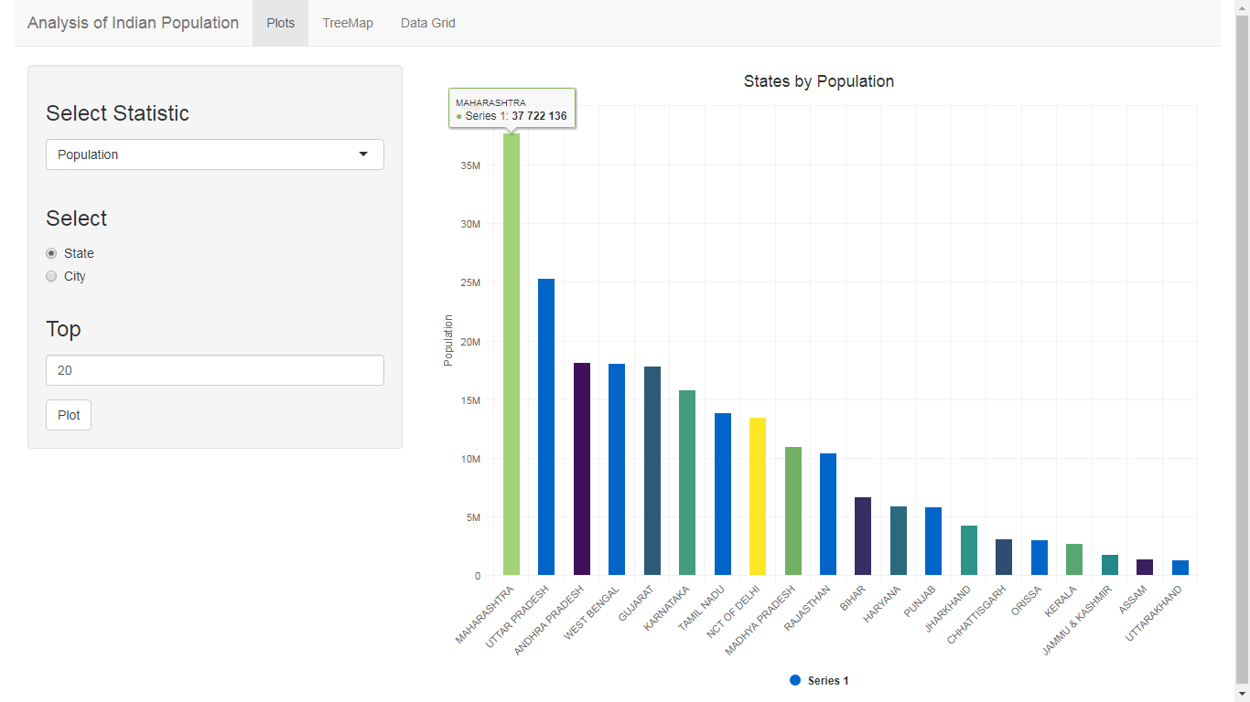

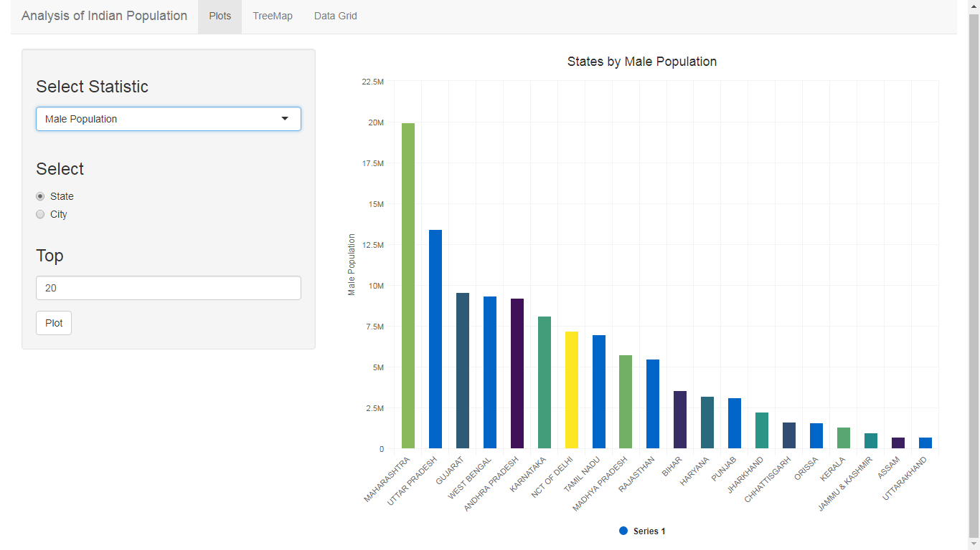

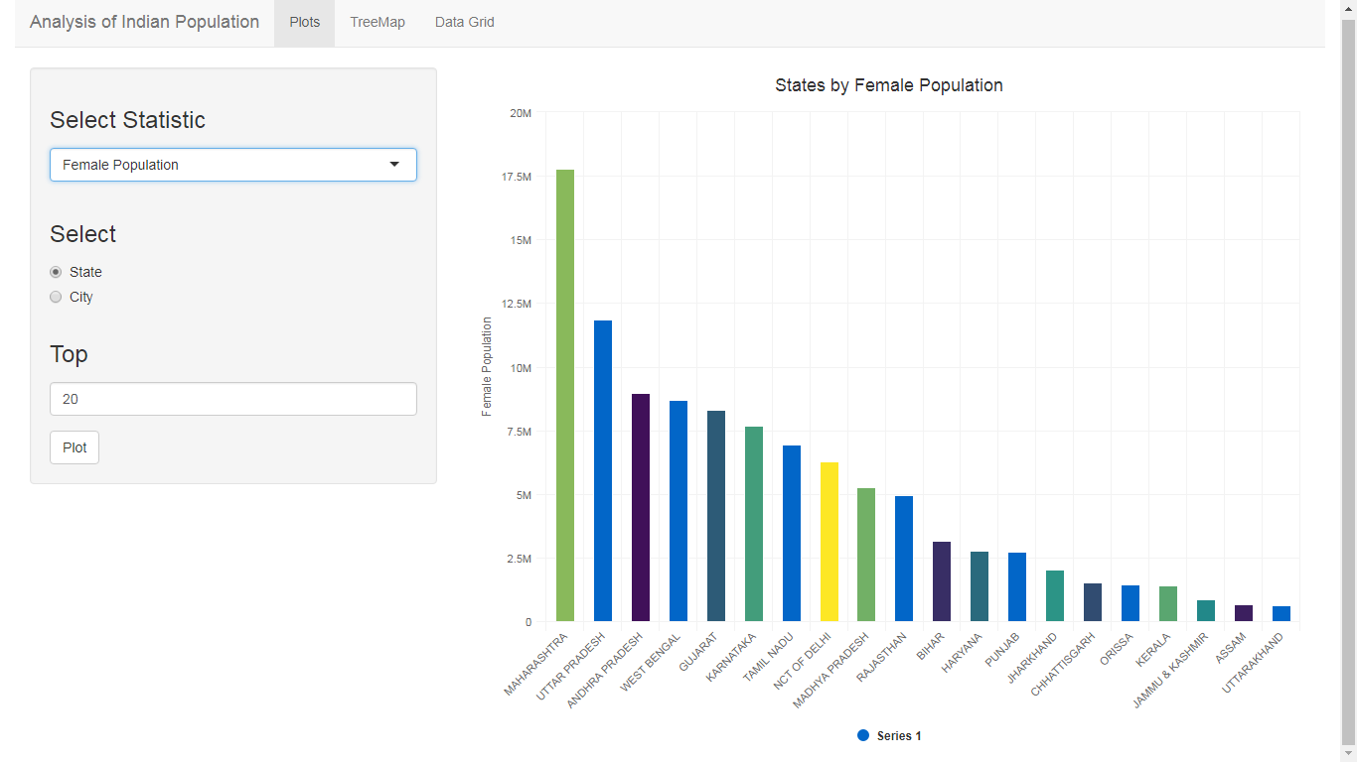

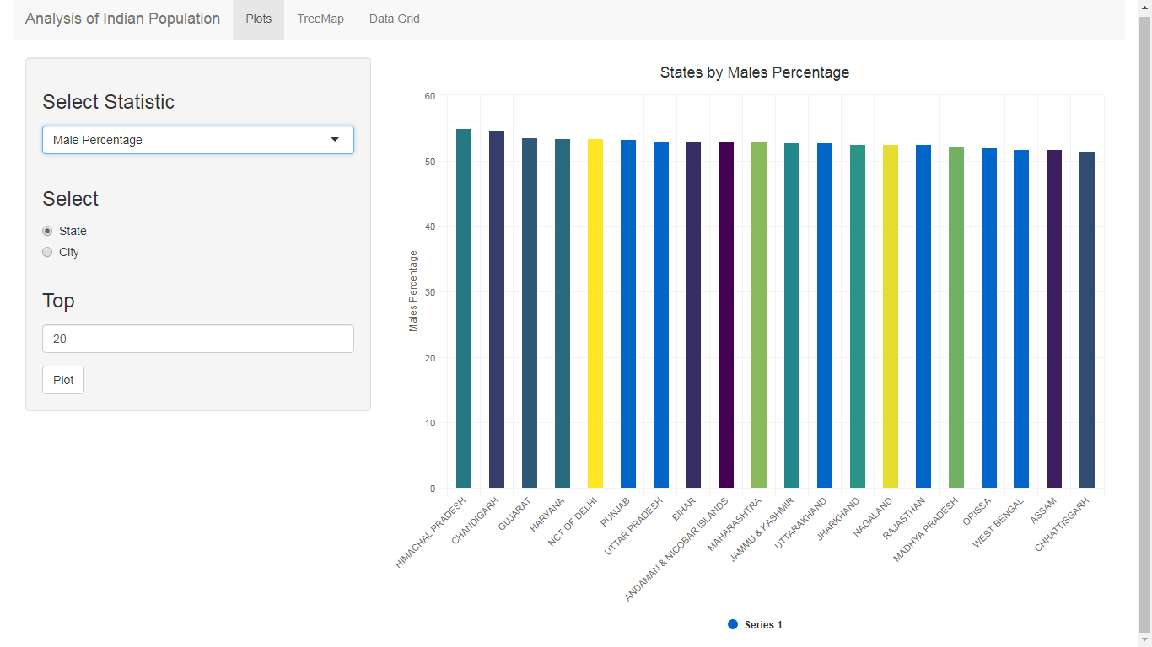

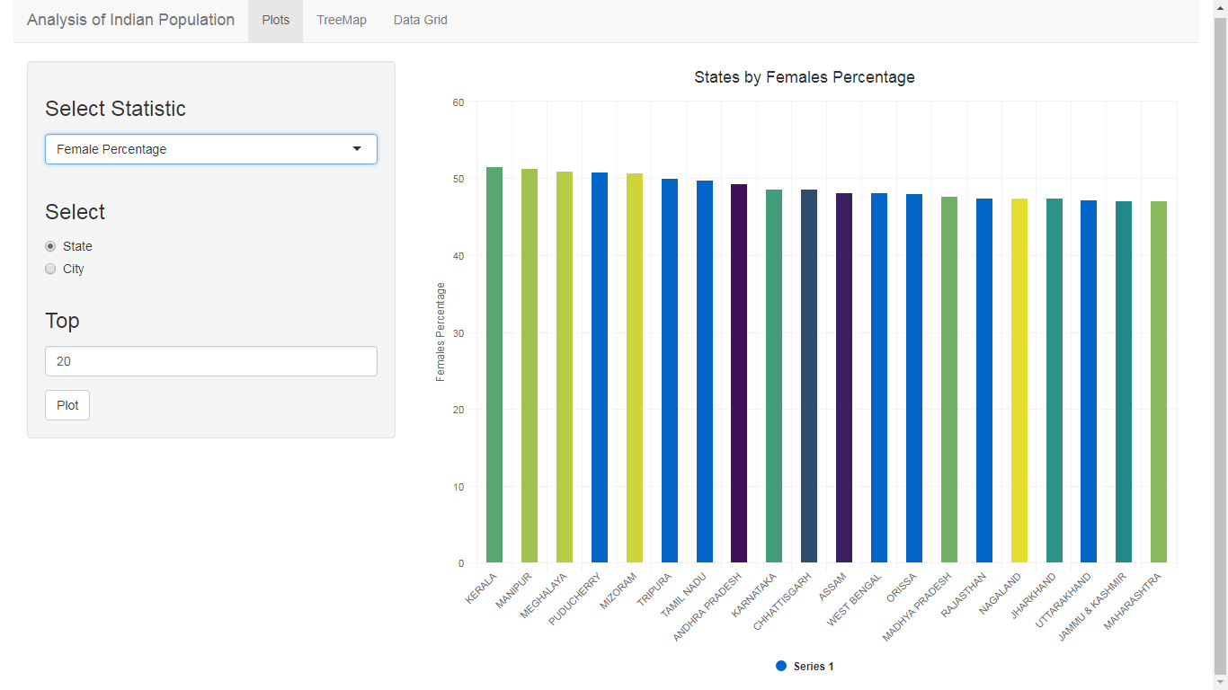

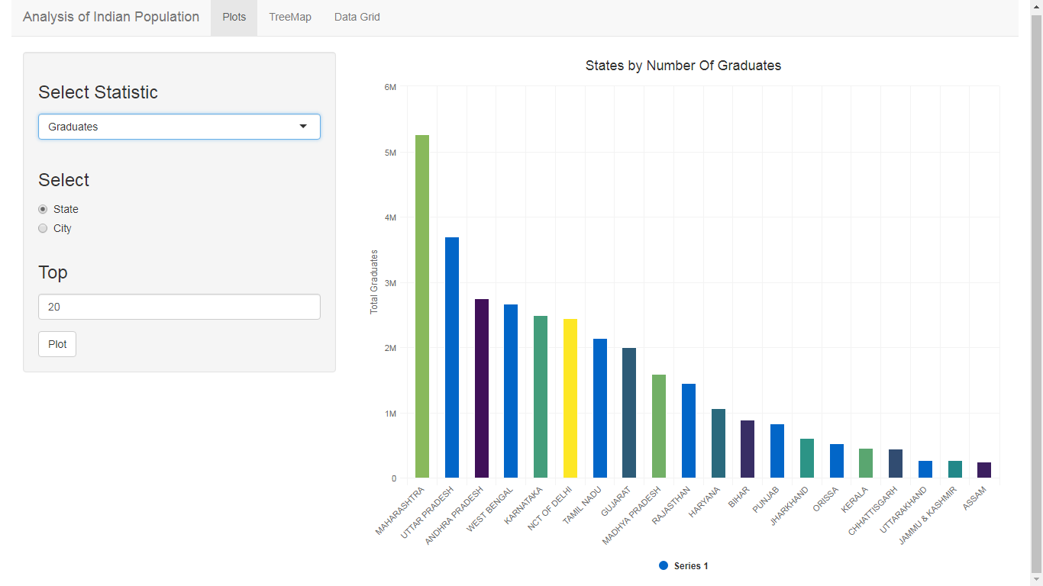

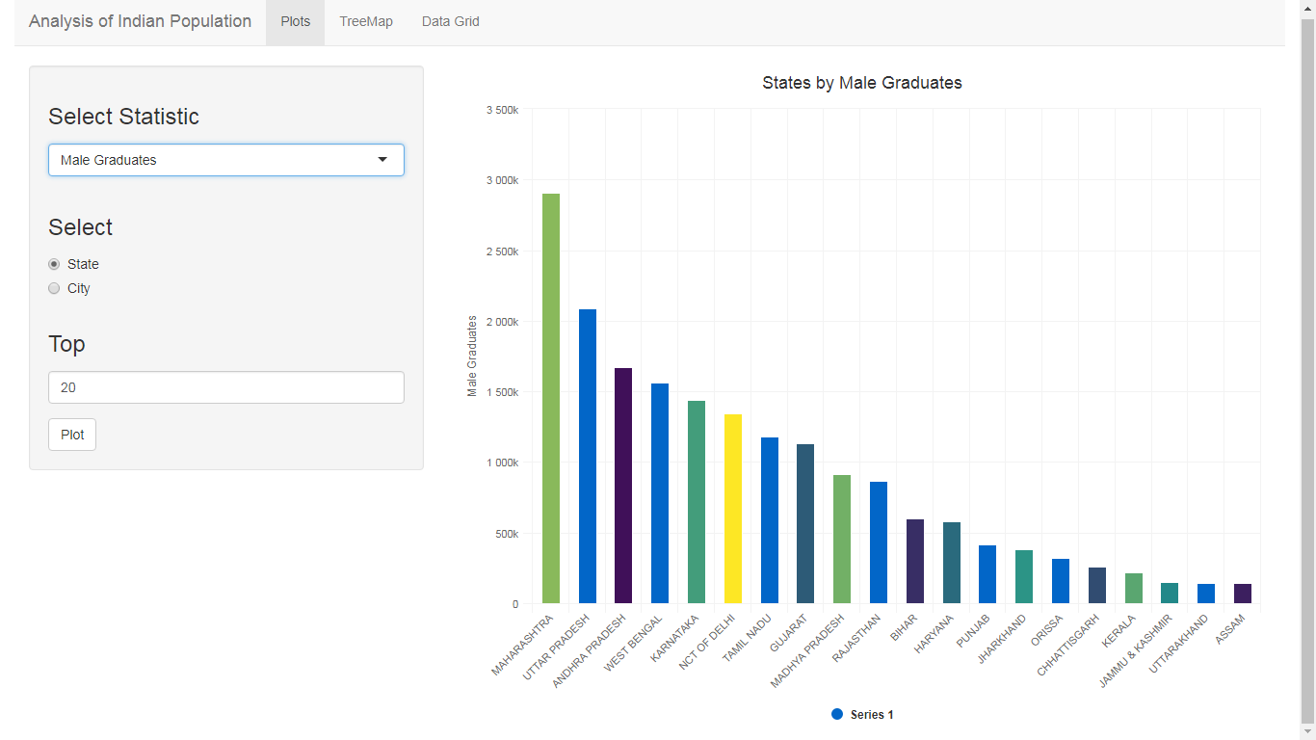

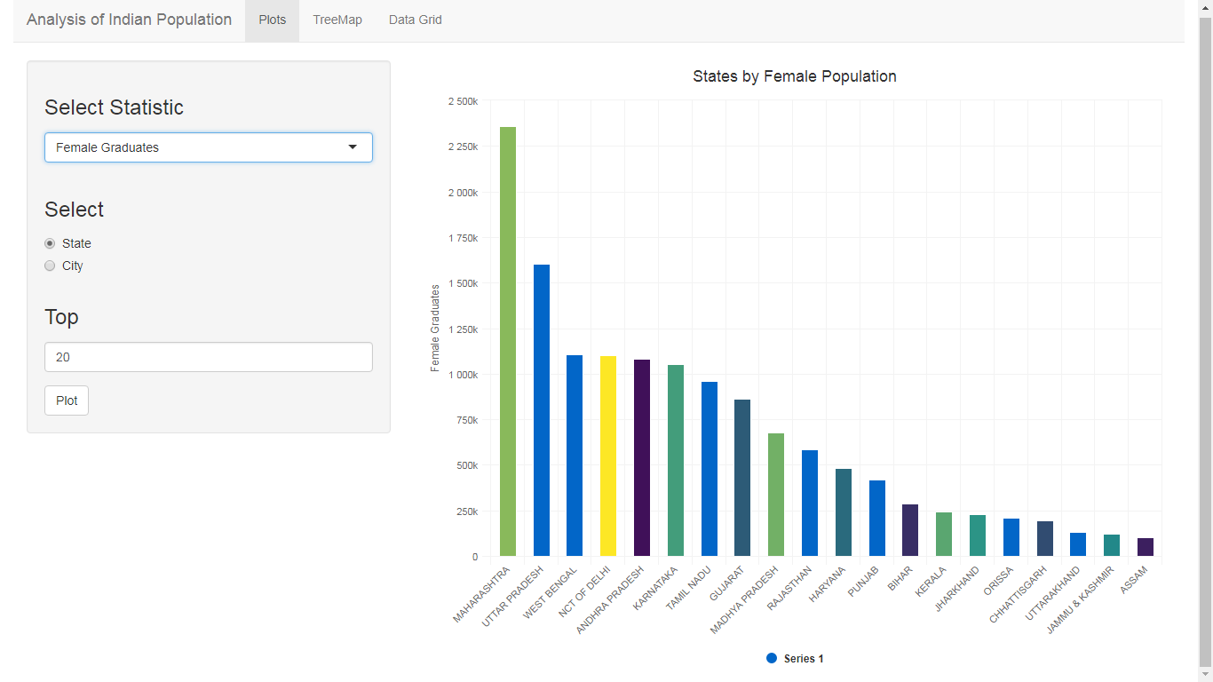

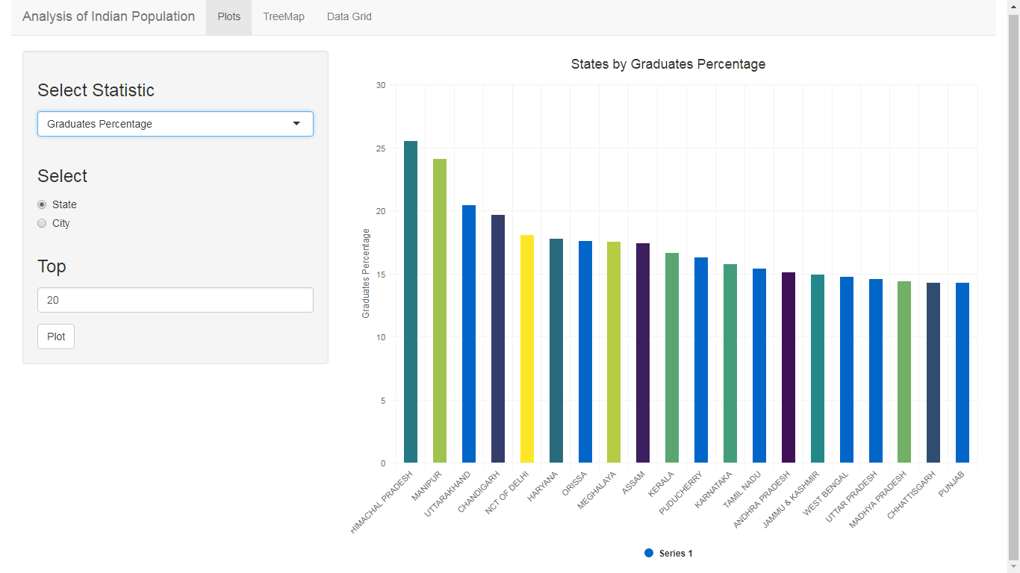

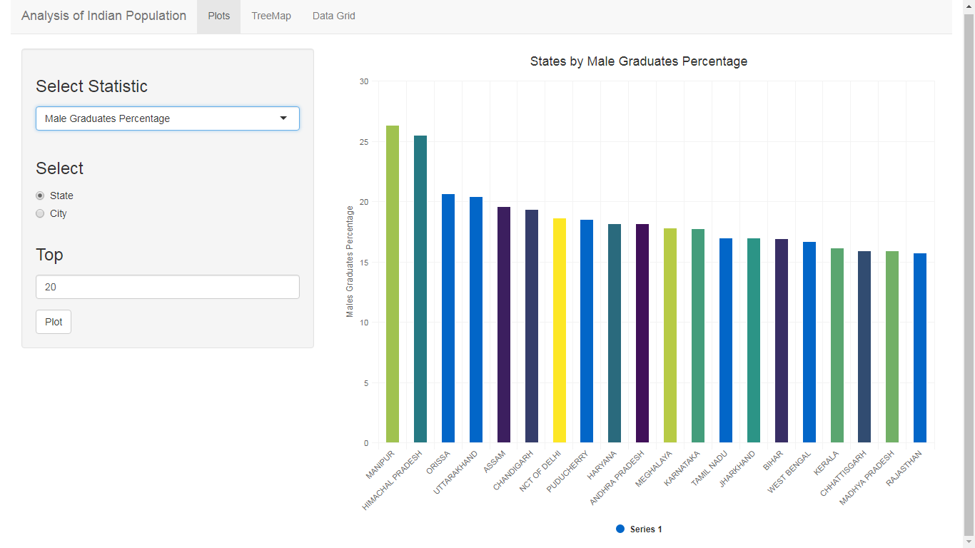 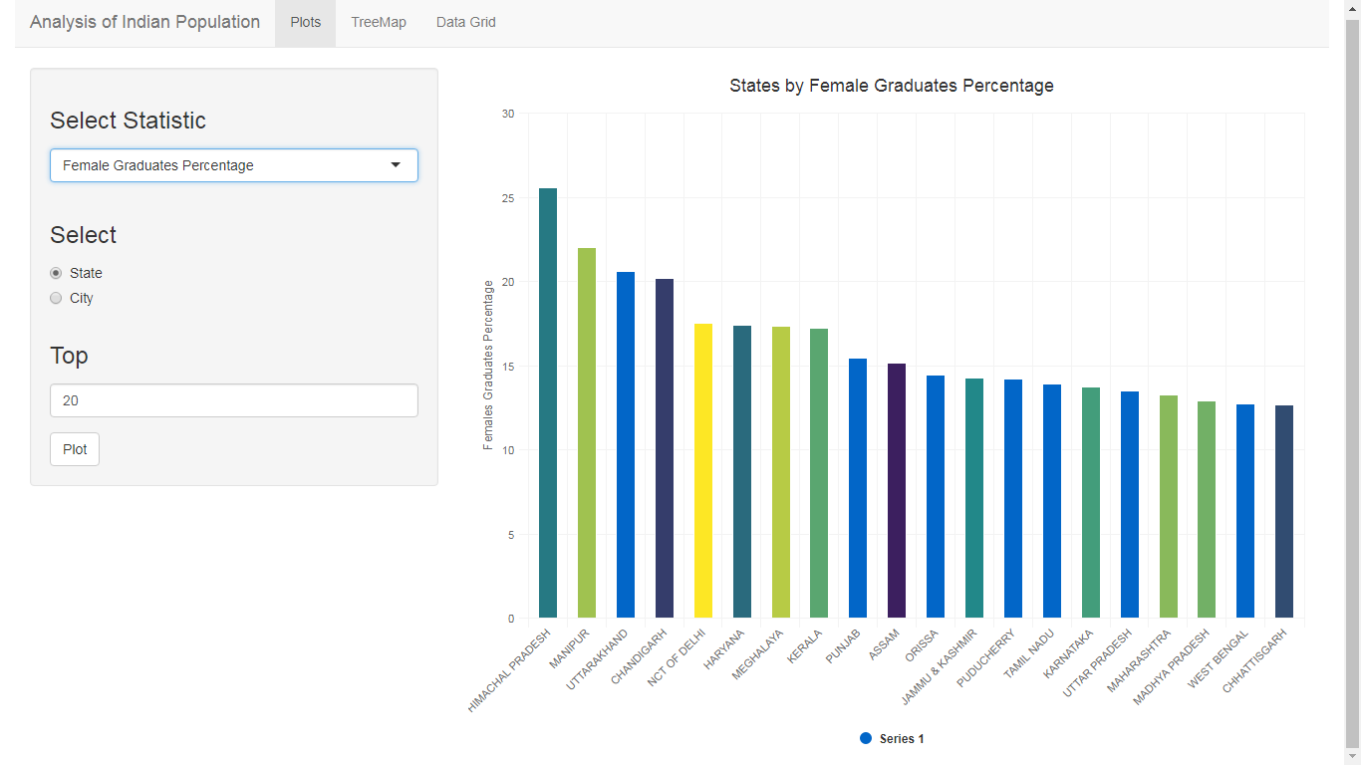

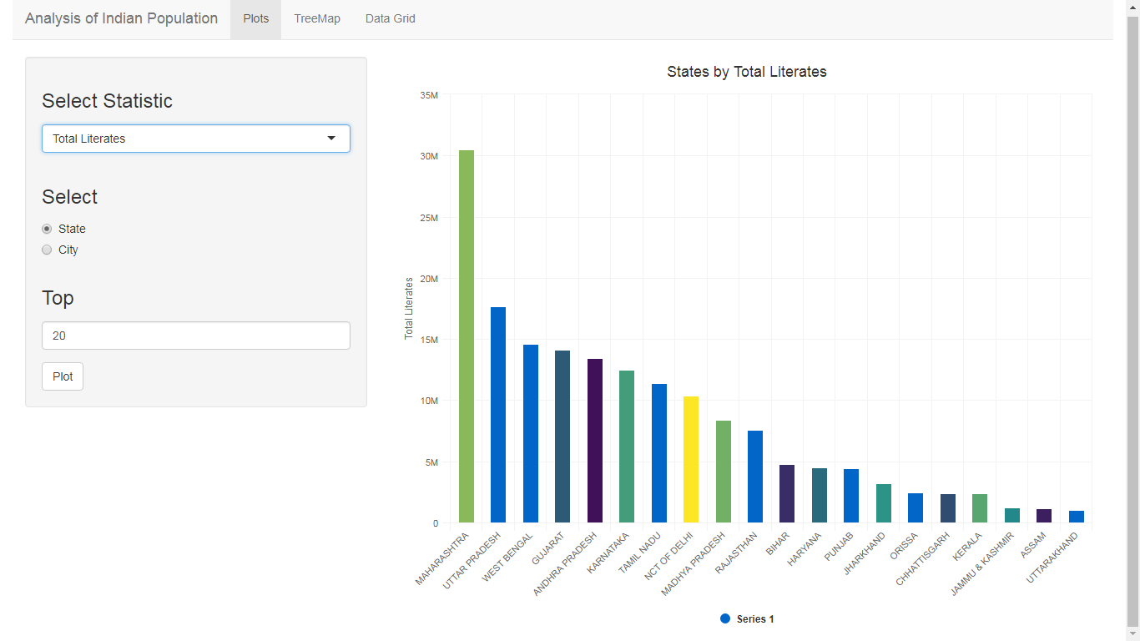

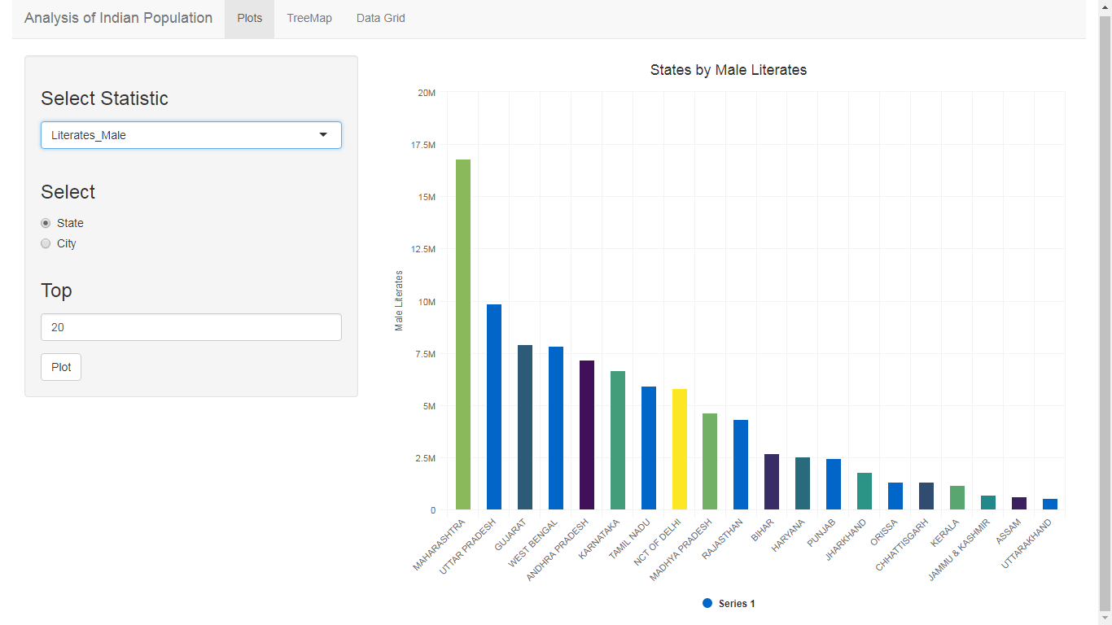

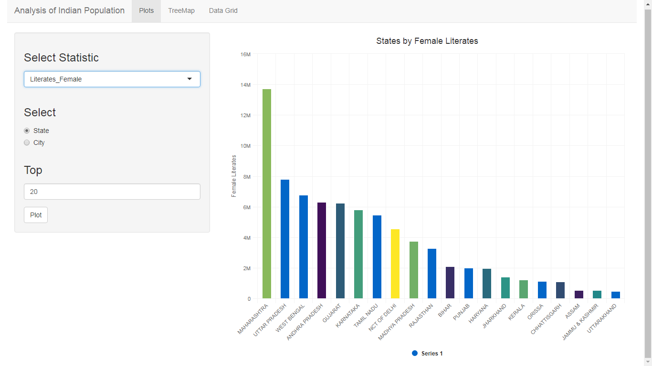

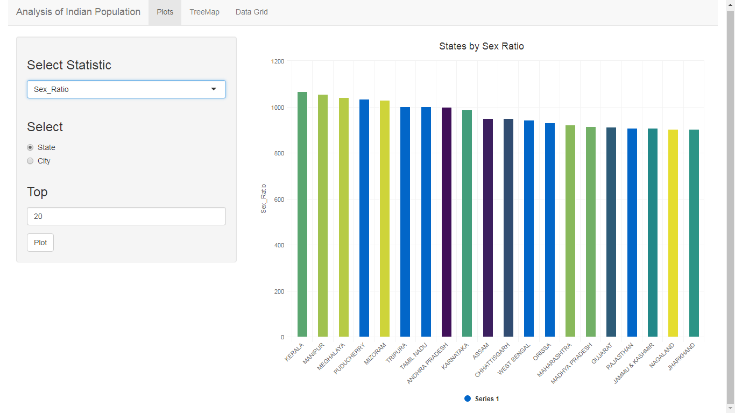

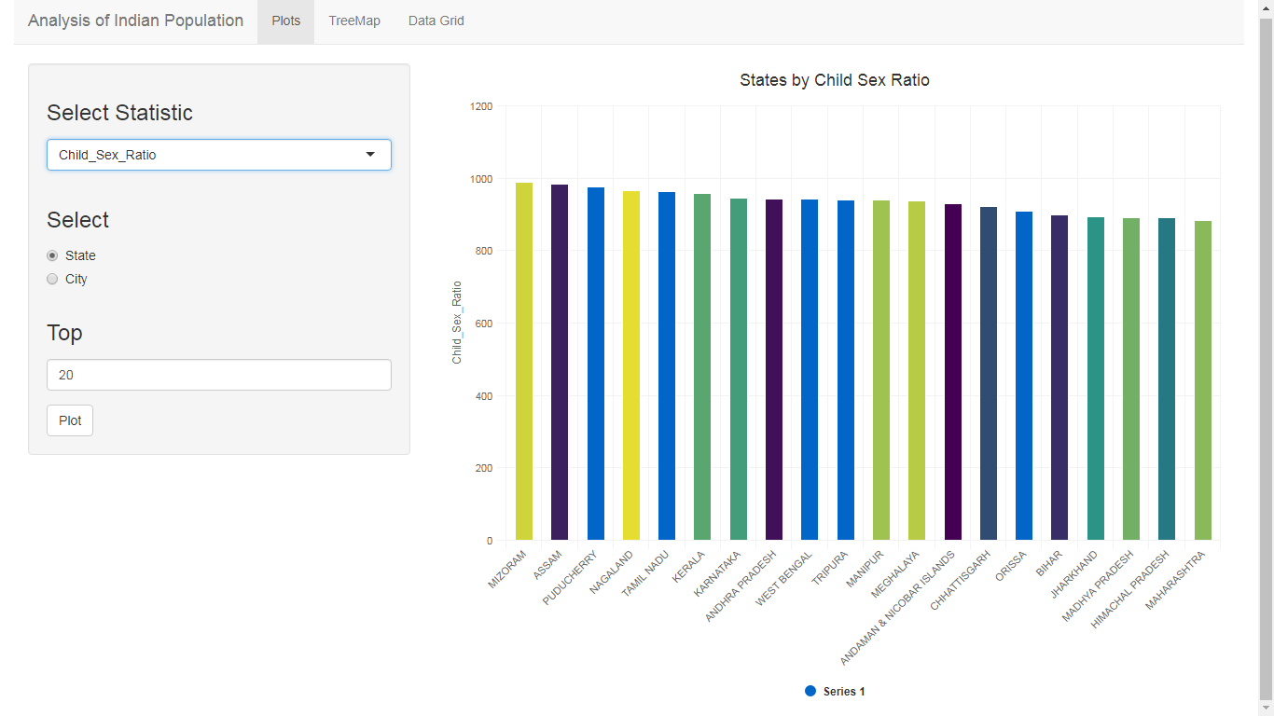

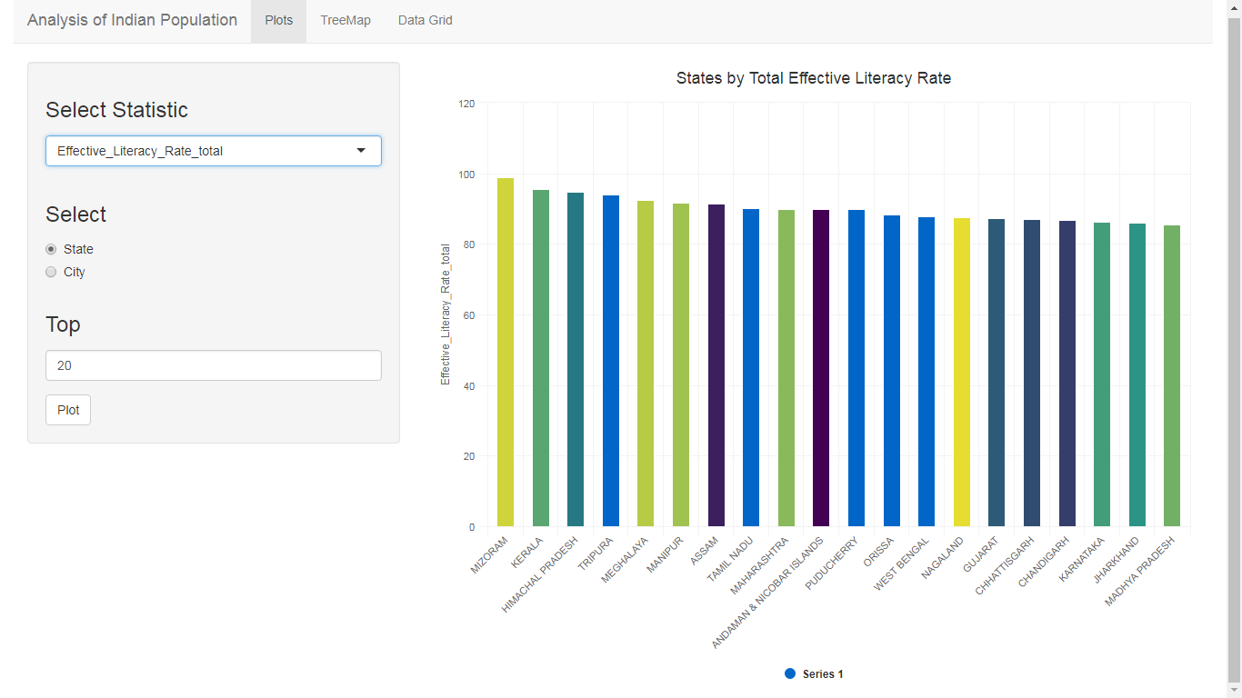

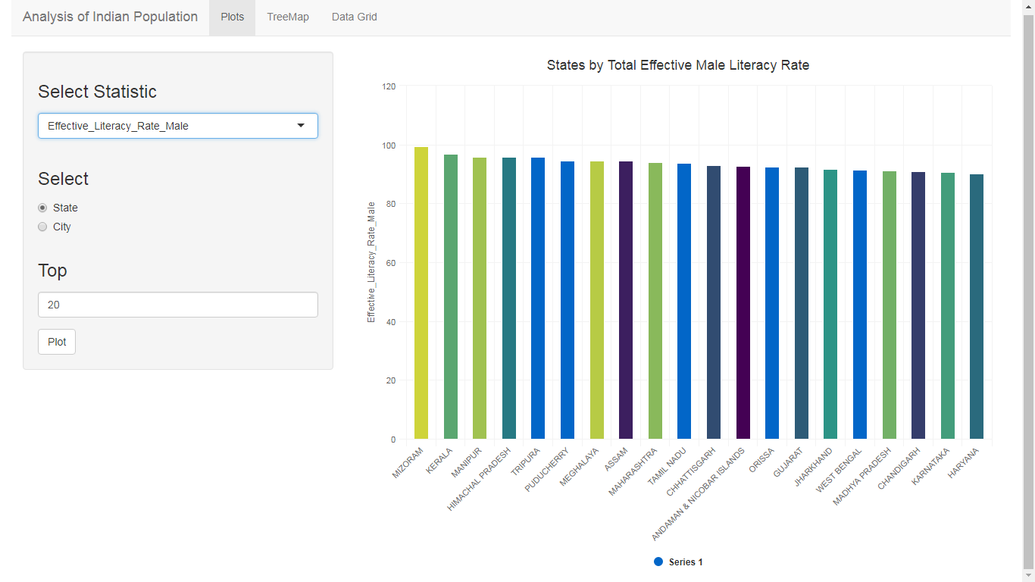

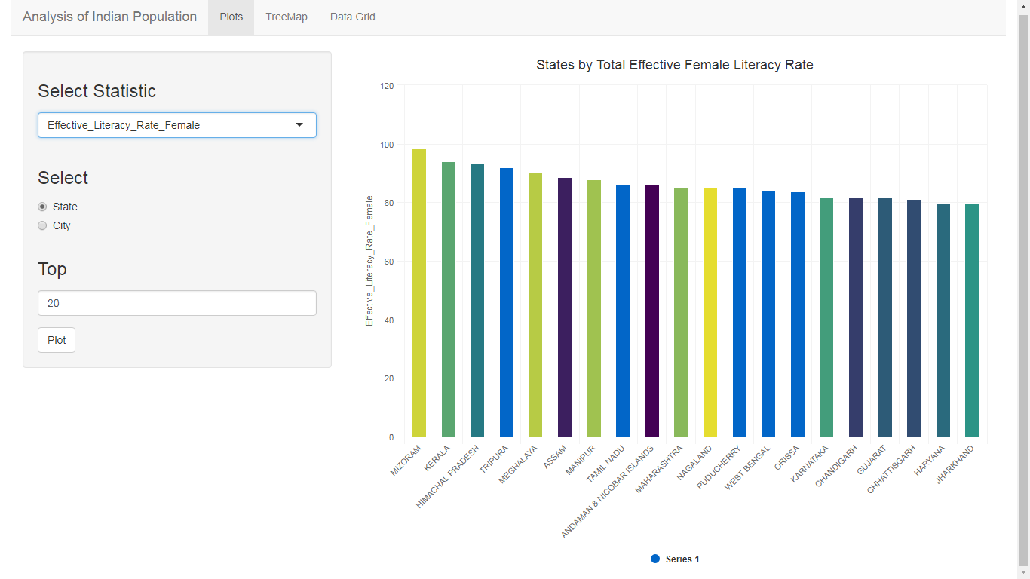

Plots for City:

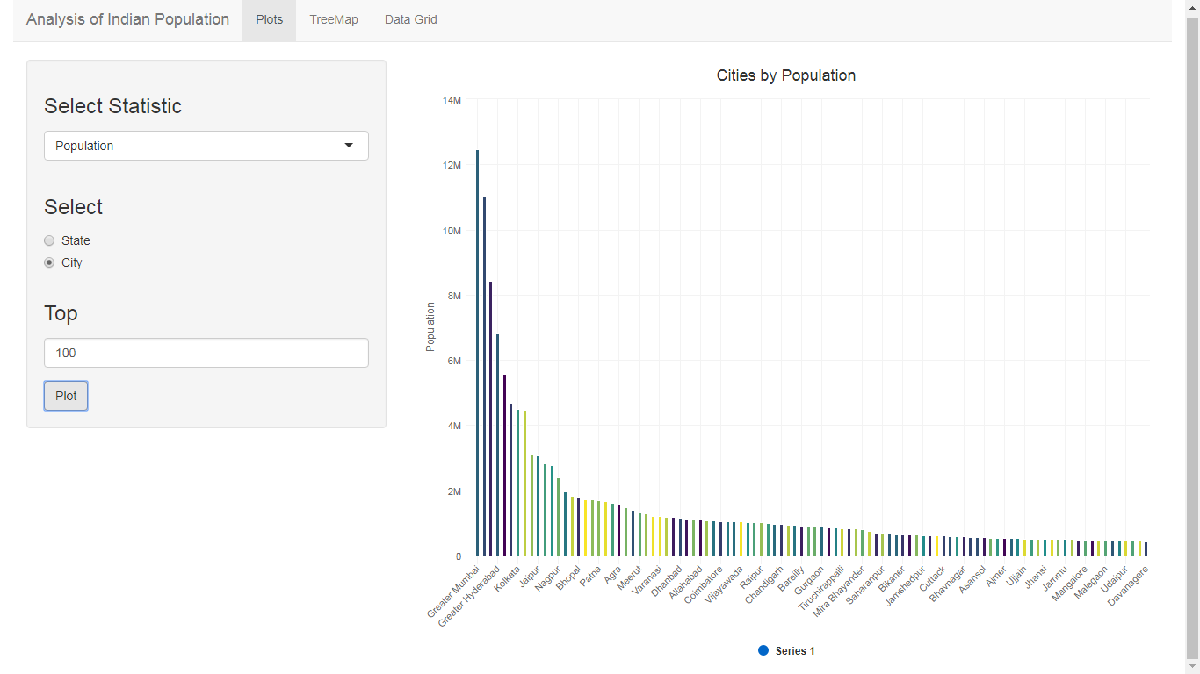

Note: There are multiple graphs for city as well. Different Graphs are displayed as you change the statistics.

1. Tree Map.

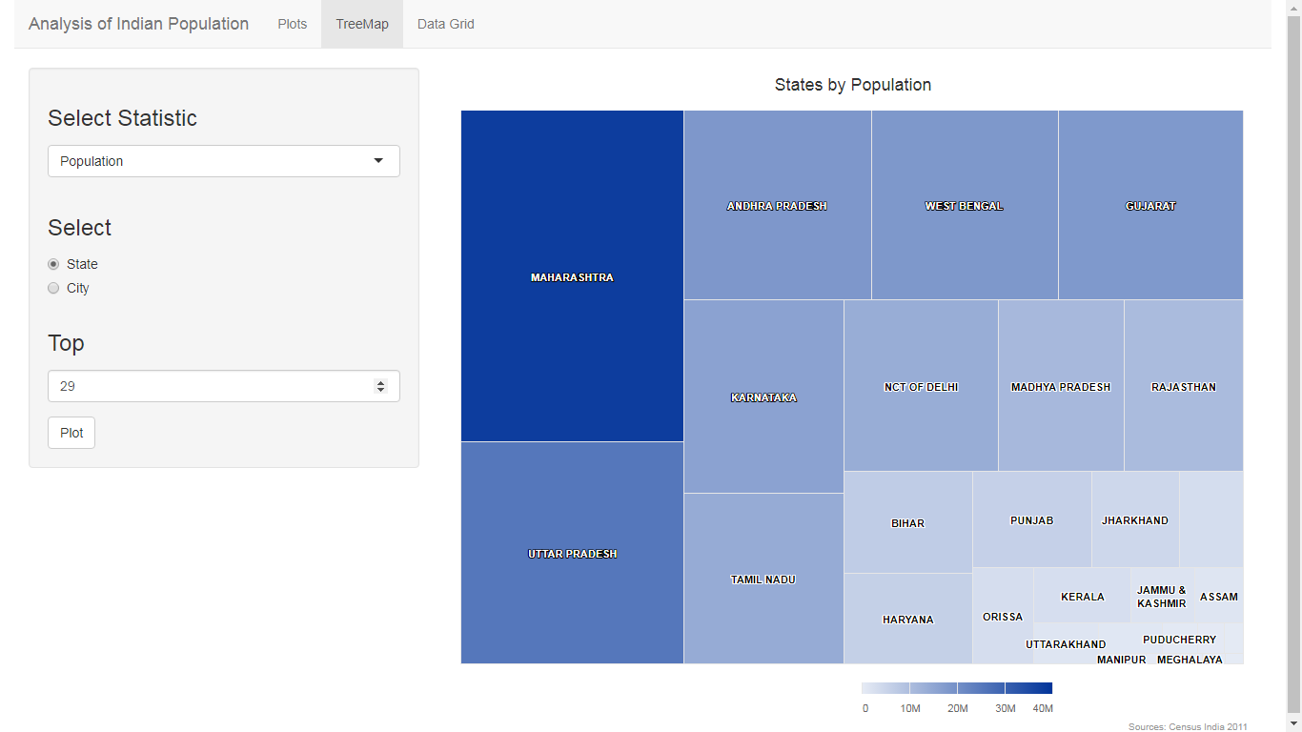

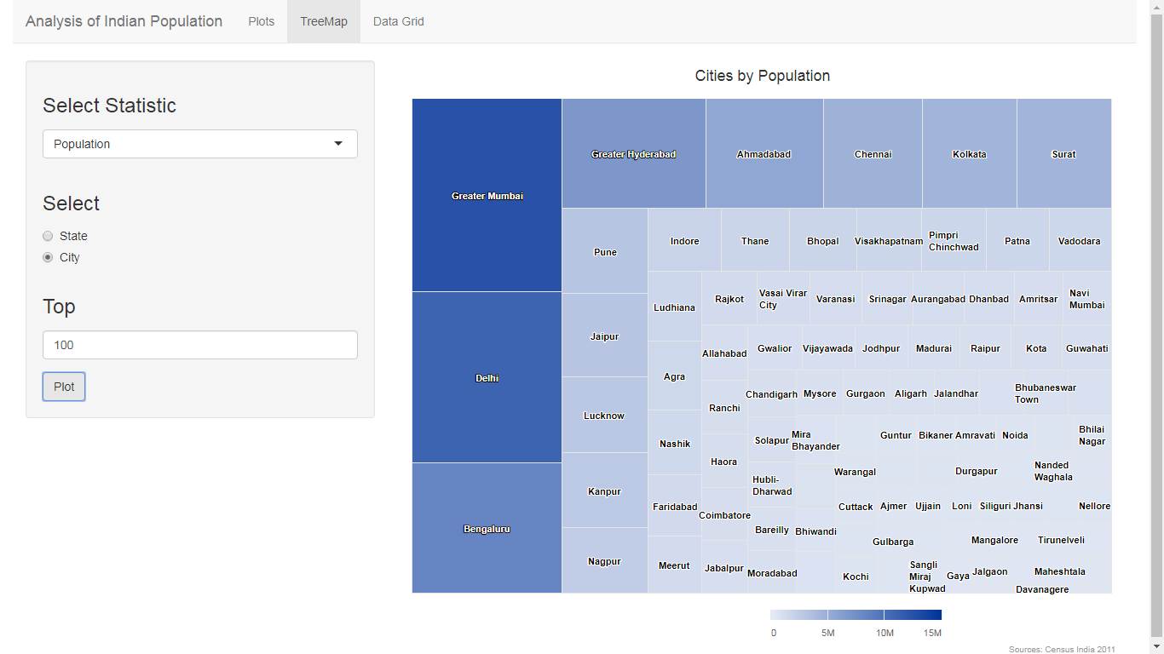

Note: There are multiple tree map as well. Different tree maps are displayed as you change the statistics for both cities and states.

1. Data Grid:

For States:

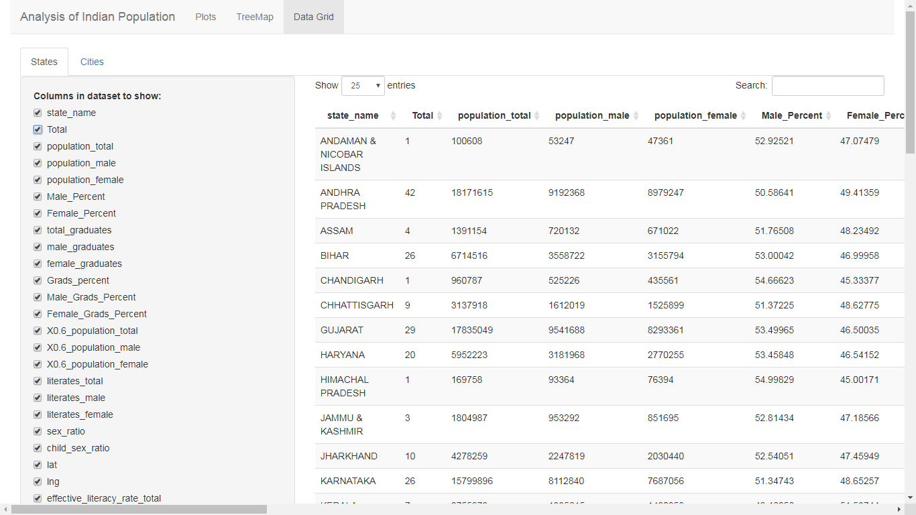

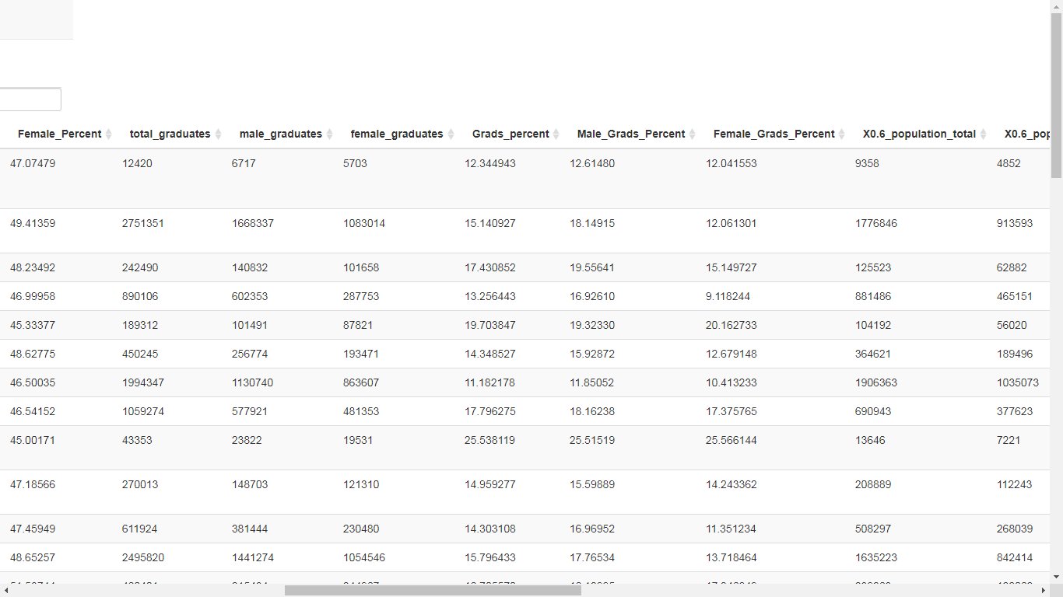

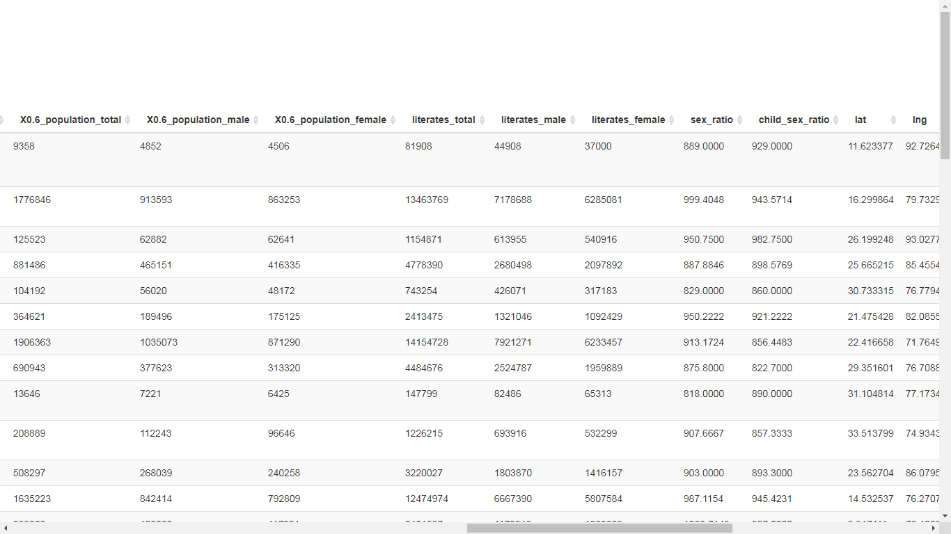

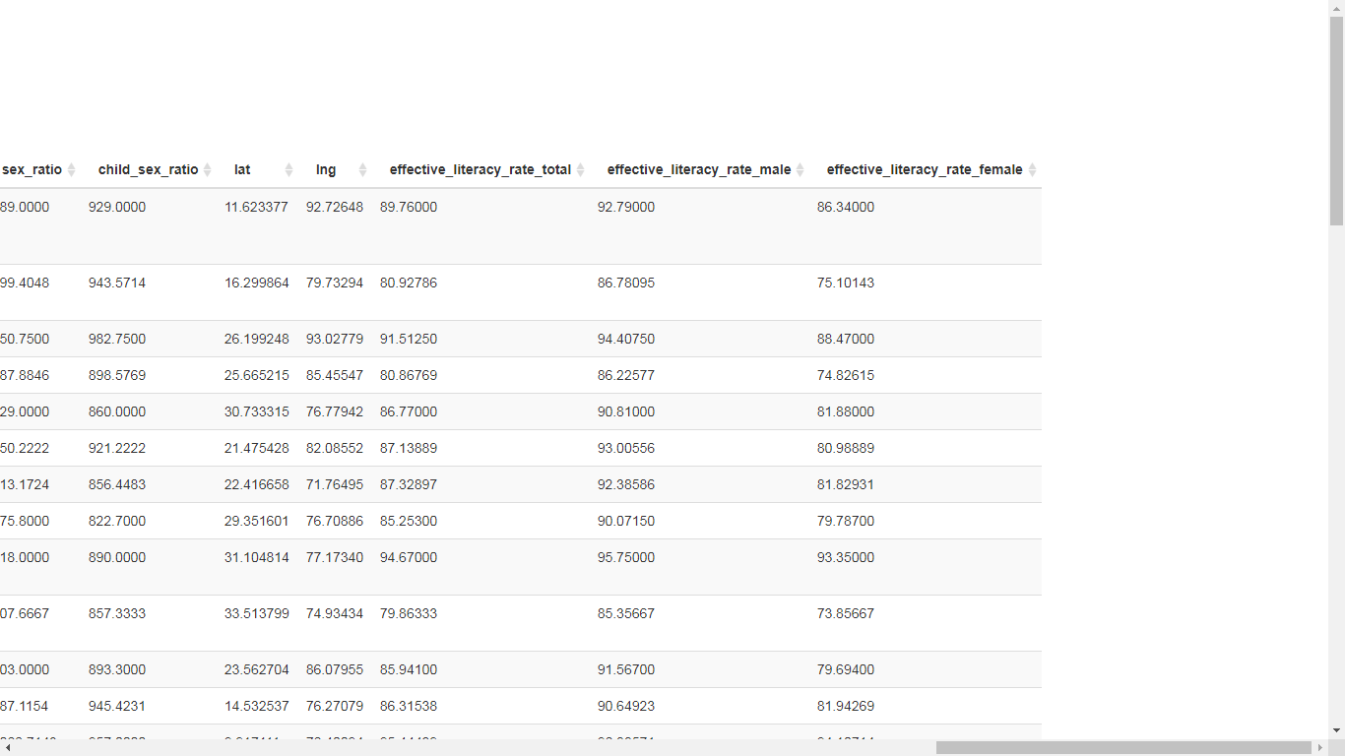

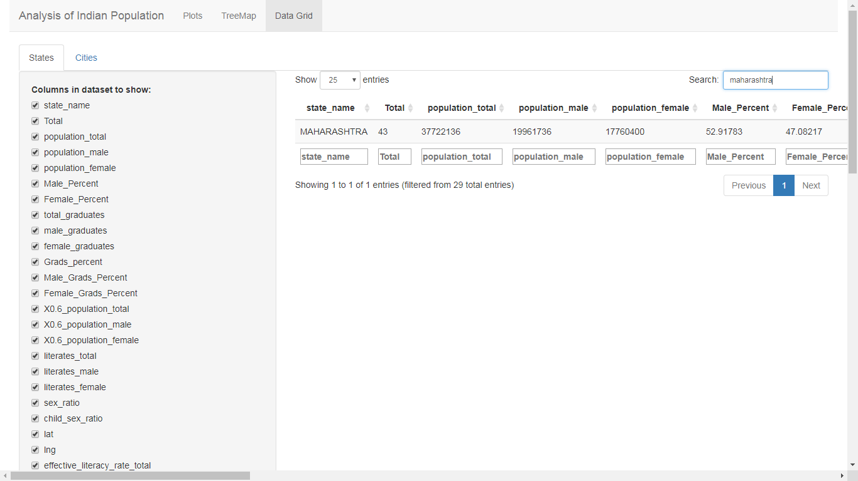

For Cities:

